Objective Question

Question 1: Are there any tables with duplicate or missing null values? If so, how would you handle them?

Answer:-

- SQL Code:

-- NULL VALUES CHECK
-- users
SELECT *
FROM users
WHERE username IS NULL OR created_at IS NULL;

-- photos (note: column is created_dat)
SELECT *
FROM photos
WHERE image_url IS NULL OR user_id IS NULL OR created_dat IS NULL;

-- comments
SELECT *
FROM comments
WHERE comment_text IS NULL OR user_id IS NULL OR photo_id IS NULL;

-- likes
SELECT *
FROM likes
WHERE user_id IS NULL OR photo_id IS NULL;

-- follows
SELECT *
FROM follows
WHERE follower_id IS NULL OR followee_id IS NULL;

-- tags
SELECT *
FROM tags
WHERE tag_name IS NULL;

-- photo_tags
SELECT *
FROM photo_tags
WHERE photo_id IS NULL OR tag_id IS NULL;

-- DUPLICATES CHECK

-- users (duplicate usernames)
SELECT username, COUNT(*) AS duplicate_count
FROM users
GROUP BY username
HAVING COUNT(*) > 1;

-- photos (duplicate URLs)
SELECT image_url, COUNT(*) AS duplicate_count
FROM photos
GROUP BY image_url
HAVING COUNT(*) > 1;

-- comments (same comment by same user on same photo)
SELECT comment_text, user_id, photo_id, COUNT(*) AS duplicate_count
FROM comments
GROUP BY comment_text, user_id, photo_id
HAVING COUNT(*) > 1;

-- likes
SELECT user_id, photo_id, COUNT(*)
FROM likes
GROUP BY user_id, photo_id
HAVING COUNT(*) > 1;

-- follows
SELECT follower_id, followee_id, COUNT(*)
FROM follows
GROUP BY follower_id, followee_id
HAVING COUNT(*) > 1;

-- tags (duplicate tag names)
SELECT tag_name, COUNT(*) AS duplicate_count
FROM tags
GROUP BY tag_name
HAVING COUNT(*) > 1;

-- Photo_Tages
SELECT photo_id, tag_id, COUNT(*)
FROM photo_tags
GROUP BY photo_id, tag_id
HAVING COUNT(*) > 1;

- Output:

Screenshot 1:
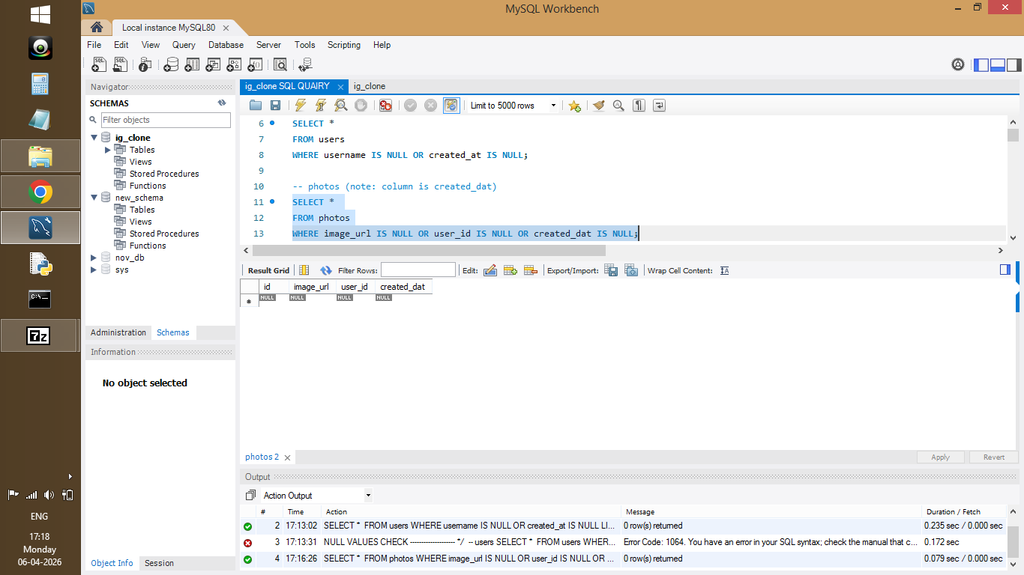
Figure 1: NULL values check – No missing values found

Screenshot 2:
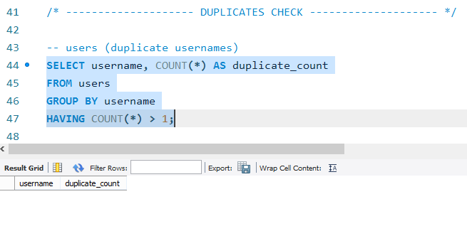Figure 2: Duplicate values check – No duplicates found

Brief Explanation:

• All tables were checked for NULL values and duplicate records using SQL queries.

• No NULL values or duplicate records were found, indicating good data quality.

• Clean data ensures accurate analysis and reliable results.

• If issues were present, they could be handled using COALESCE(), DISTINCT, or constraints like PRIMARY KEY and UNIQUE.

Question 2: What is the distribution of user activity levels (posts, likes, comments) across the user base?

Answer:-

- SQL Code:

WITH user_posts AS (
SELECT user_id, COUNT(*) AS total_posts
FROM photos
GROUP BY user_id
),

user_likes AS (
SELECT user_id, COUNT(*) AS total_likes
FROM likes
GROUP BY user_id
),

user_comments AS (
SELECT user_id, COUNT(*) AS total_comments
FROM comments
GROUP BY user_id
),

user_activity AS (
SELECT
u.id,
COALESCE(p.total_posts, 0) AS posts,
COALESCE(l.total_likes, 0) AS likes,
COALESCE(c.total_comments, 0) AS comments,
COALESCE(p.total_posts, 0)
+ COALESCE(l.total_likes, 0)
+ COALESCE(c.total_comments, 0) AS total_activity
FROM users u
LEFT JOIN user_posts p ON u.id = p.user_id
LEFT JOIN user_likes l ON u.id = l.user_id
LEFT JOIN user_comments c ON u.id = c.user_id
)

SELECT
CASE
WHEN total_activity = 0 THEN 'Inactive'
WHEN total_activity BETWEEN 1 AND 50 THEN 'Low Activity'
WHEN total_activity BETWEEN 51 AND 200 THEN 'Medium Activity'
ELSE 'High Activity'
END AS activity_level,
COUNT(*) AS user_count
FROM user_activity
GROUP BY activity_level
ORDER BY user_count DESC;

- Output:
Screenshot 3:
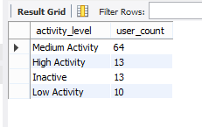
Figure 3: Distribution of user activity levels (query output)

- Visualization:

Screenshot 4:
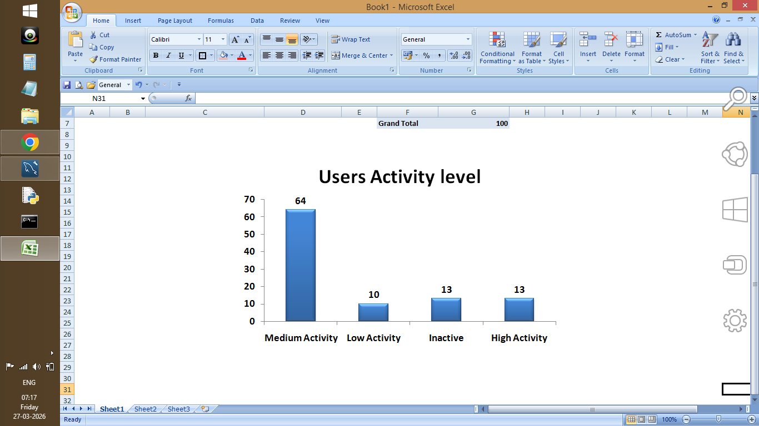
Figure 4: Visualization of user activity levels distribution

Bar chart showing number of users in each activity level (Inactive, Low, Medium, High).

- Brief Explanation:

• User activity was calculated using total posts, likes, and comments.

• Users were categorized into Inactive, Low, Medium, and High activity levels.

• Most users fall under the medium activity category.

• A small group of users contributes to high engagement.

Question 3: Calculate the average number of tags per post (photo_tags and photos tables).

Answer:

- SQL Code:

WITH tag_count AS (
SELECT
p.id,
COUNT(pt.tag_id) AS tags_per_post
FROM photos p
LEFT JOIN photo_tags pt
ON p.id = pt.photo_id
GROUP BY p.id
)

SELECT
ROUND(AVG(tags_per_post), 2) AS avg_tags_per_post
FROM tag_count;

- Output:

Screenshot 5:

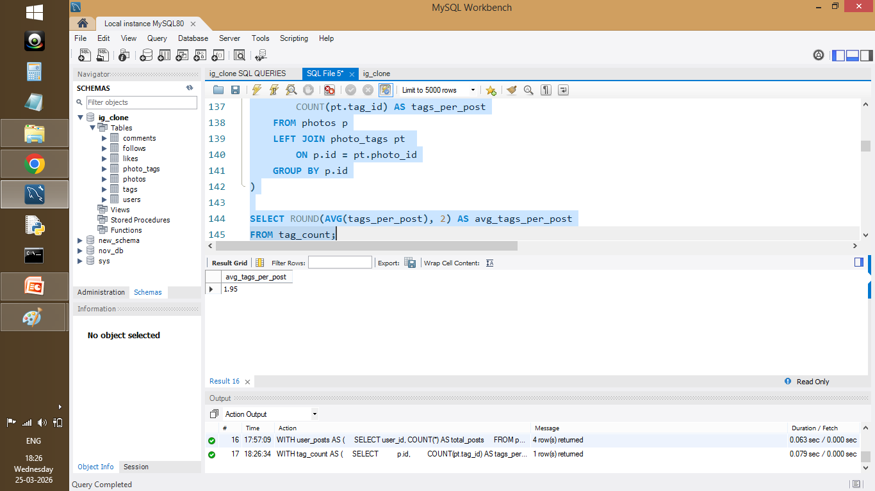

Figure 5: Average number of tags per post

- Brief Explanation:

• The number of tags per post was calculated using photos and photo_tags tables.

• Average tags per post were computed using the AVG() function.

• This shows how frequently hashtags are used in content.

• Hashtags help improve content visibility and reach.

Question 4: Identify the top users with the highest engagement rates (likes, comments) on their posts and rank them ?

Answer:

- SQL Code:

WITH user_posts AS (
SELECT user_id, COUNT(*) AS total_posts
FROM photos
GROUP BY user_id
),

likes_received AS (
SELECT p.user_id, COUNT(*) AS total_likes
FROM photos p
JOIN likes l
ON p.id = l.photo_id
GROUP BY p.user_id
),

comments_received AS (
SELECT p.user_id, COUNT(*) AS total_comments
FROM photos p
JOIN comments c
ON p.id = c.photo_id
GROUP BY p.user_id
),

engagement_data AS (
SELECT
u.id,
u.username,
COALESCE(up.total_posts, 0) AS total_posts,
COALESCE(lr.total_likes, 0) AS total_likes,
COALESCE(cr.total_comments, 0) AS total_comments
FROM users u
LEFT JOIN user_posts up ON u.id = up.user_id
LEFT JOIN likes_received lr ON u.id = lr.user_id
LEFT JOIN comments_received cr ON u.id = cr.user_id
)

SELECT
id,
username,
total_posts,
total_likes,
total_comments,
ROUND(
(total_likes + total_comments) * 1.0 / NULLIF(total_posts, 0),
2
) AS engagement_rate,
RANK() OVER (
ORDER BY
(total_likes + total_comments) * 1.0 / NULLIF(total_posts, 0) DESC
) AS user_rank
FROM engagement_data
WHERE total_posts > 0;

- Output:

Screenshot 6:
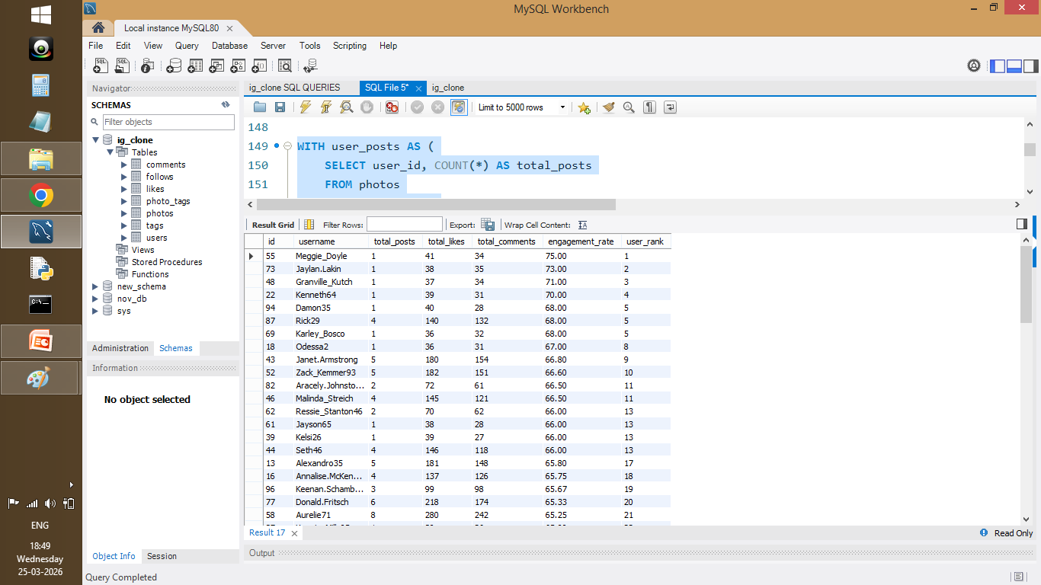

Figure 6: Top users ranked by engagement rate

- Visualization:

Screenshot 7:
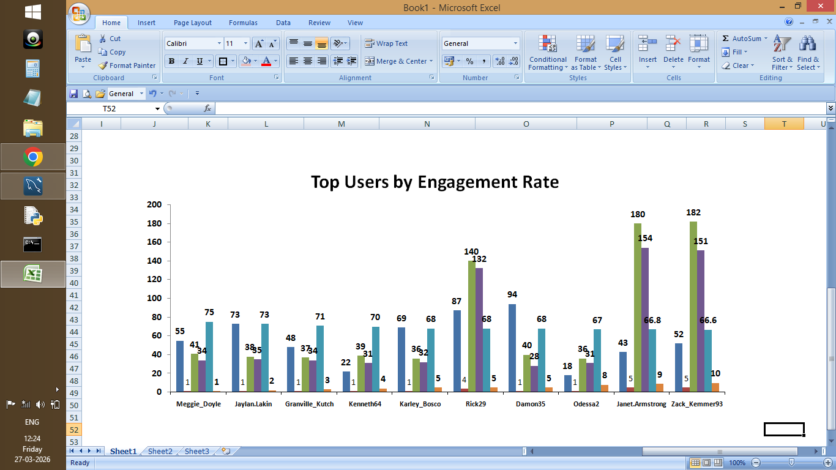

Figure 7: Visualization of top users by engagement rate

• Engagement rate was calculated using total likes and comments per post.

• Users were ranked using a window function (RANK).

• Top users generate high interaction on their content.

• These users can be considered potential influencers.

Question 5: Which users have the highest number of followers and followings?

Answer:

- SQL Code:

WITH followers_count AS (
SELECT
followee_id AS user_id,
COUNT(*) AS total_followers
FROM follows
GROUP BY followee_id
),

following_count AS (
SELECT
follower_id AS user_id,
COUNT(*) AS total_following
FROM follows
GROUP BY follower_id
)

SELECT
u.id,
u.username,
COALESCE(fc.total_followers, 0) AS total_followers,
COALESCE(fg.total_following, 0) AS total_following
FROM users u
LEFT JOIN followers_count fc
ON u.id = fc.user_id
LEFT JOIN following_count fg
ON u.id = fg.user_id
ORDER BY total_followers DESC, total_following DESC;

- Output:

Screenshot 8:
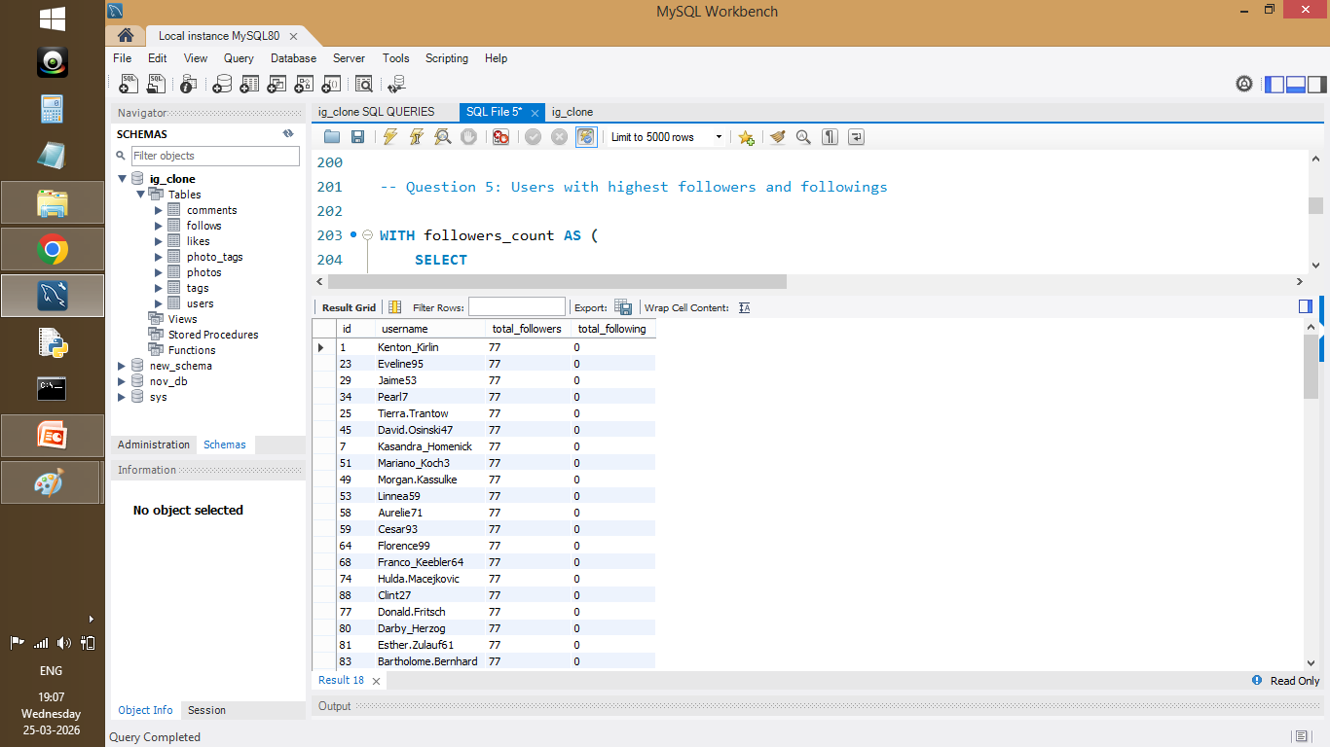
Figure 8: Users with highest followers and followings
- Visualization:
Screenshot 9:
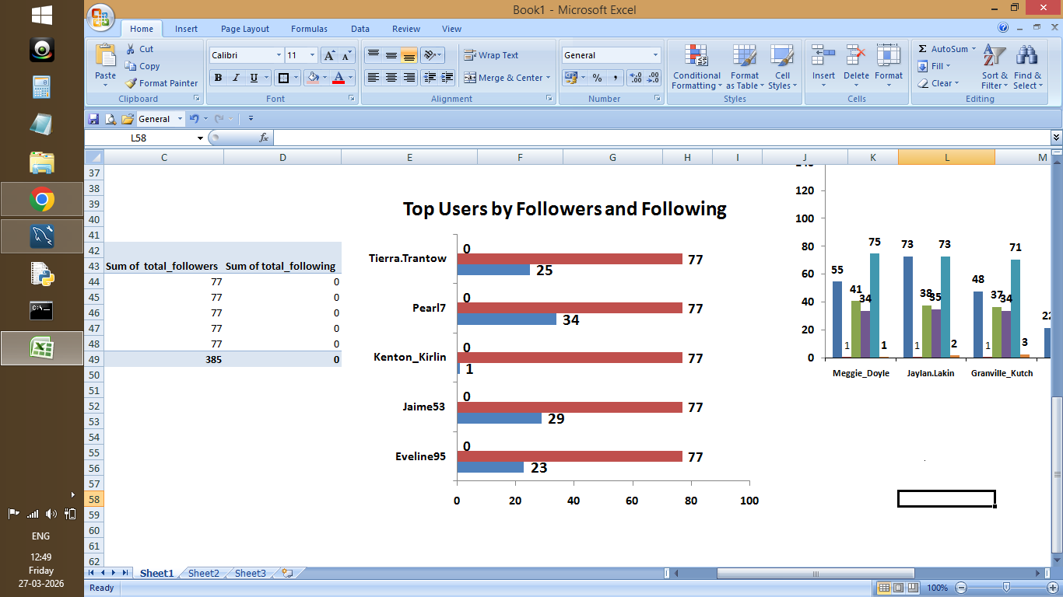
Figure 9: Comparison of followers and following Comparison

- Brief Explanation:
• Followers and followings were calculated using the follows table.

• Users with high followers indicate popularity.

• Users with high followings indicate high activity.

• This helps understand user network behavior.

Question 6: Calculate the average engagement rate (likes, comments) per post for each user.

Answer:

- SQL Code:

WITH user_posts AS (
SELECT user_id, COUNT(*) AS total_posts
FROM photos
GROUP BY user_id
),

likes_received AS (
SELECT p.user_id, COUNT(*) AS total_likes
FROM photos p
JOIN likes l
ON p.id = l.photo_id
GROUP BY p.user_id
),

comments_received AS (
SELECT p.user_id, COUNT(*) AS total_comments
FROM photos p
JOIN comments c
ON p.id = c.photo_id
GROUP BY p.user_id
),

engagement_data AS (
SELECT
u.id,
u.username,
COALESCE(up.total_posts, 0) AS total_posts,
COALESCE(lr.total_likes, 0) AS total_likes,
COALESCE(cr.total_comments, 0) AS total_comments
FROM users u
LEFT JOIN user_posts up ON u.id = up.user_id
LEFT JOIN likes_received lr ON u.id = lr.user_id
LEFT JOIN comments_received cr ON u.id = cr.user_id
)

SELECT
id,
username,
total_posts,
total_likes,
total_comments,
ROUND(
(total_likes + total_comments) * 1.0 / NULLIF(total_posts, 0),
2
) AS avg_engagement_per_post
FROM engagement_data
WHERE total_posts > 0
ORDER BY avg_engagement_per_post DESC;

- Output:

Screenshot 10:
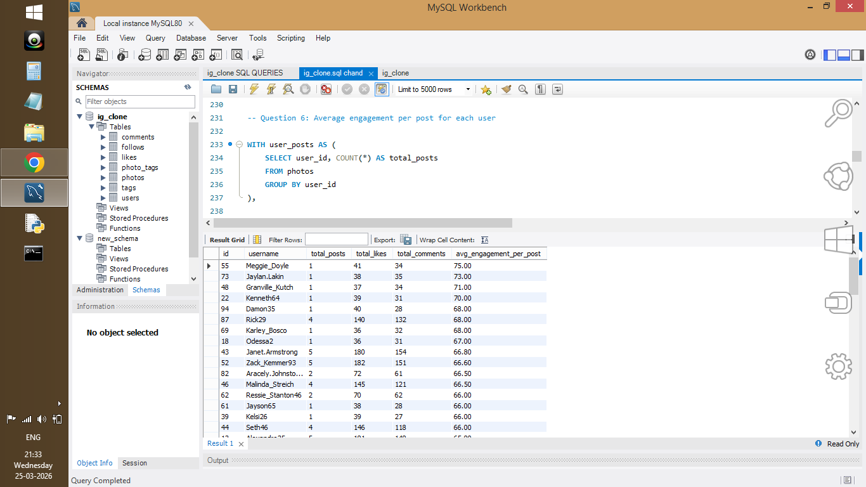
Figure 10: Average engagement per post for each user
- Visualization:
Screenshot 11:
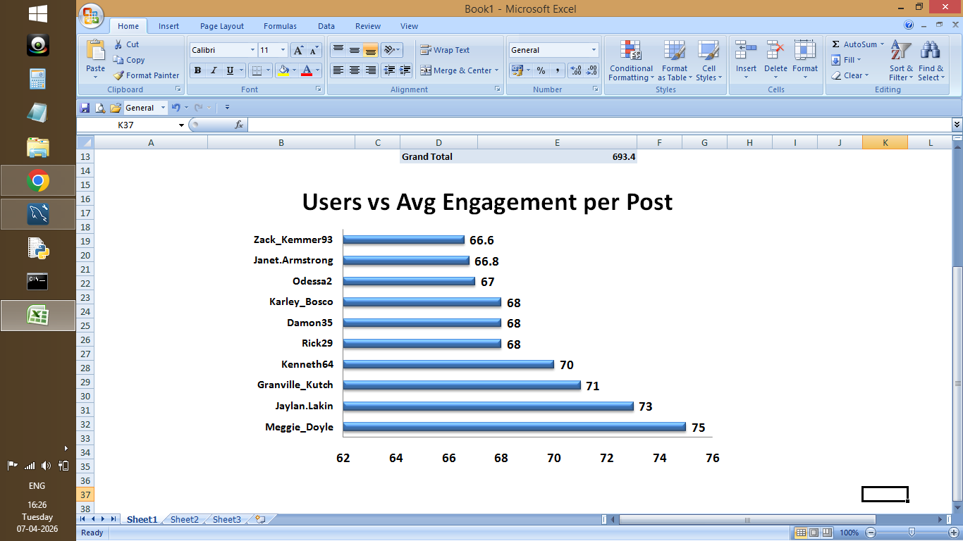
Figure 11: Users vs Avg Engagement per Post

- Brief Explanation:
• Average engagement per post was calculated using likes and comments.

• Engagement was normalized by total posts for each user.

• This shows how engaging each user’s content is.

• Helps identify consistent high-performing users.

Question 7: Get the list of users who have never liked any post (users and likes tables) ?

Answer:

- SQL Code:

SELECT u.id, u.username
FROM users u
WHERE NOT EXISTS (
SELECT 1
FROM likes l
WHERE l.user_id = u.id
);

- Output:

Screenshot 12:
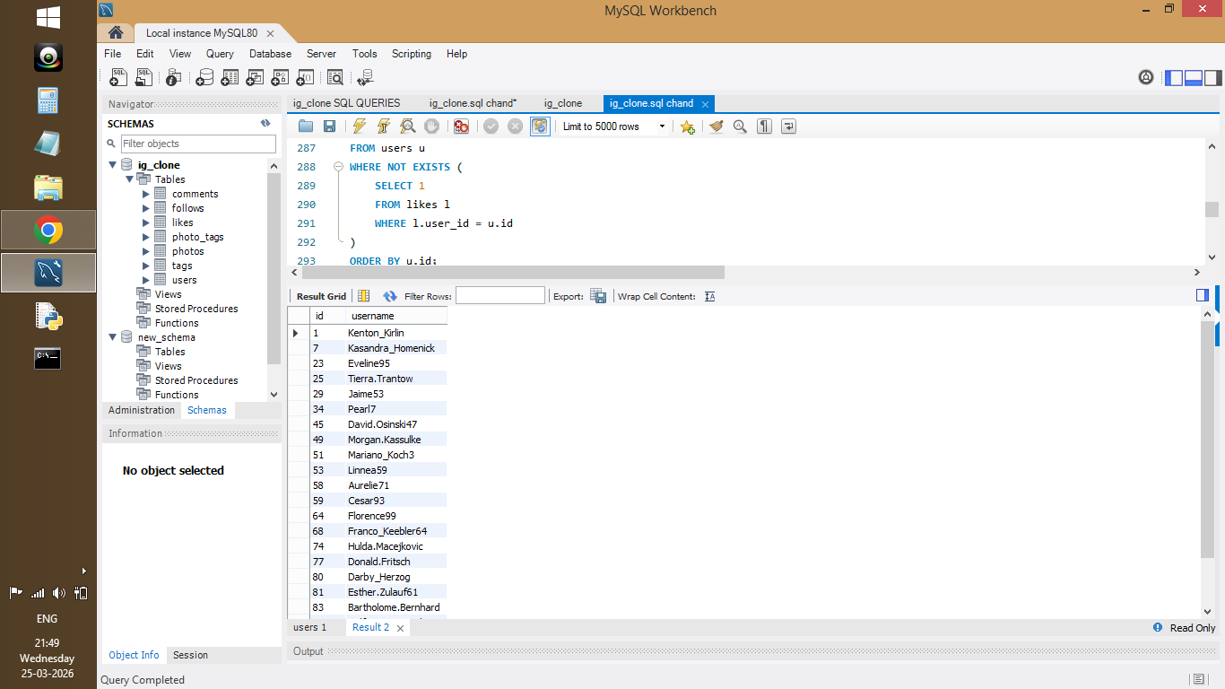

Figure 12: Users who have never liked any Post

- Brief Explanation:

• Users who never liked any post were identified using NOT EXISTS.

• These users show low interaction behavior.

• They can be targeted for engagement improvement.

Question 8: How can user-generated content be leveraged for personalized and engaging ad campaigns?

Answer:

- SQL Code:

SELECT t.tag_name, COUNT(*) AS usage_count
FROM tags t
JOIN photo_tags pt ON t.id = pt.tag_id
GROUP BY t.tag_name
ORDER BY usage_count DESC;

- Output:

Screenshot 13:
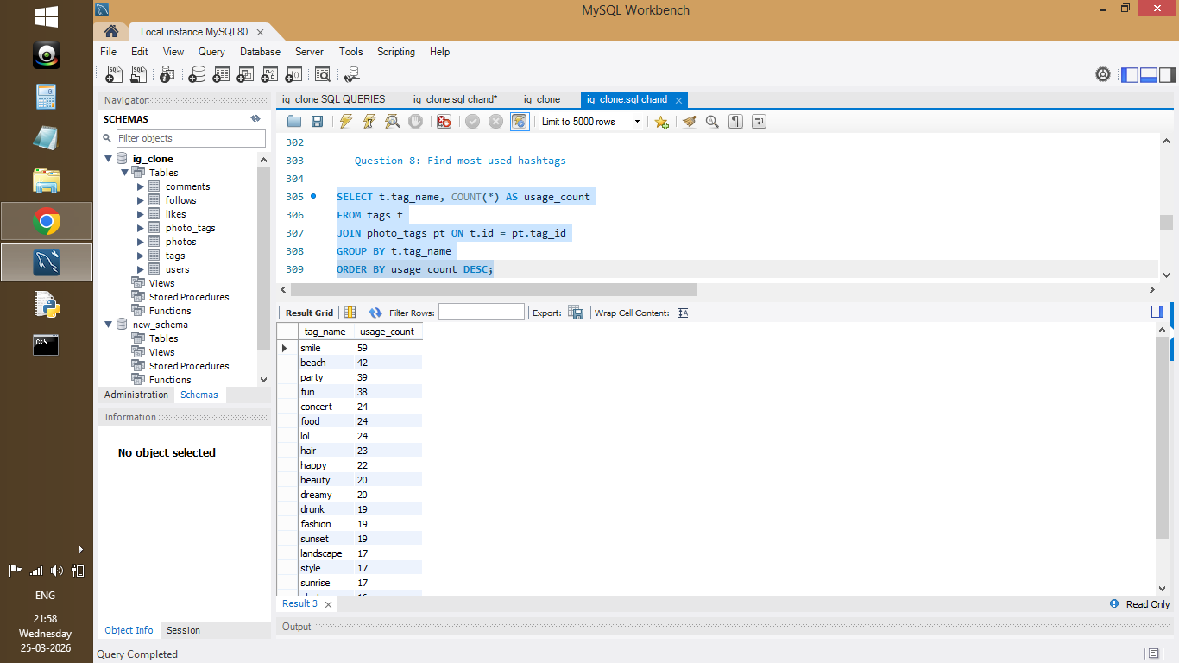

Figure 13: Most frequently used hashtags

- Visualization:

Screenshot 14:
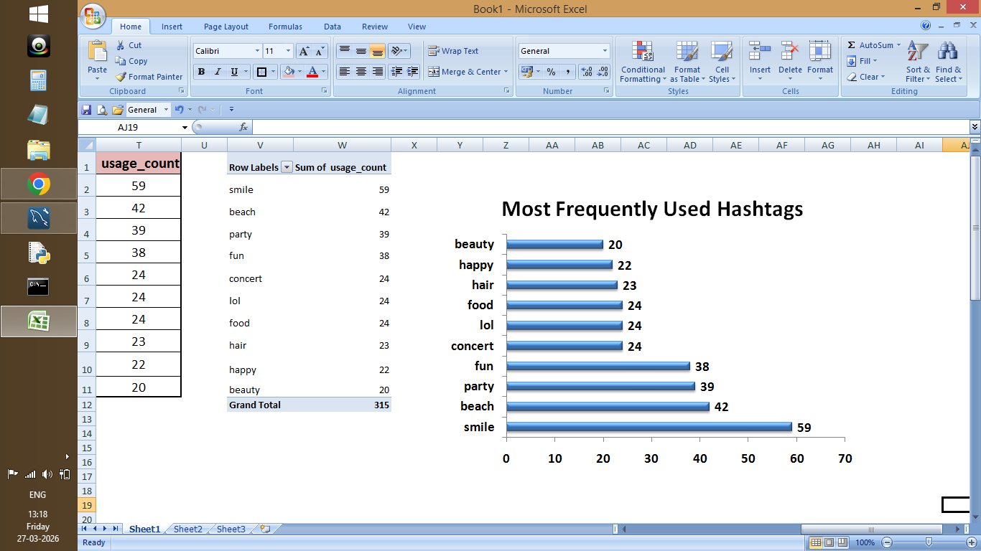
Figure 14: Most frequently used hashtags (visual representation)

- Brief Explanation:

• Most frequently used hashtags were identified.

• These hashtags represent trending content topics.

• Can be used for personalized ad targeting.

• Helps improve campaign reach and engagement.

Question 9: Are there any correlations between user activity levels and specific content types? How can this guide content creation and curation strategies?

Answer:

- SQL Code:

WITH user_activity AS (
SELECT
u.id,
COUNT(p.id) AS total_posts,
COUNT(l.photo_id) AS total_likes,
COUNT(c.id) AS total_comments
FROM users u
LEFT JOIN photos p ON u.id = p.user_id
LEFT JOIN likes l ON p.id = l.photo_id
LEFT JOIN comments c ON p.id = c.photo_id
GROUP BY u.id
)

SELECT
total_posts,
(total_likes + total_comments) AS avg_engagement
FROM user_activity;

- Output:

Screenshot 15:
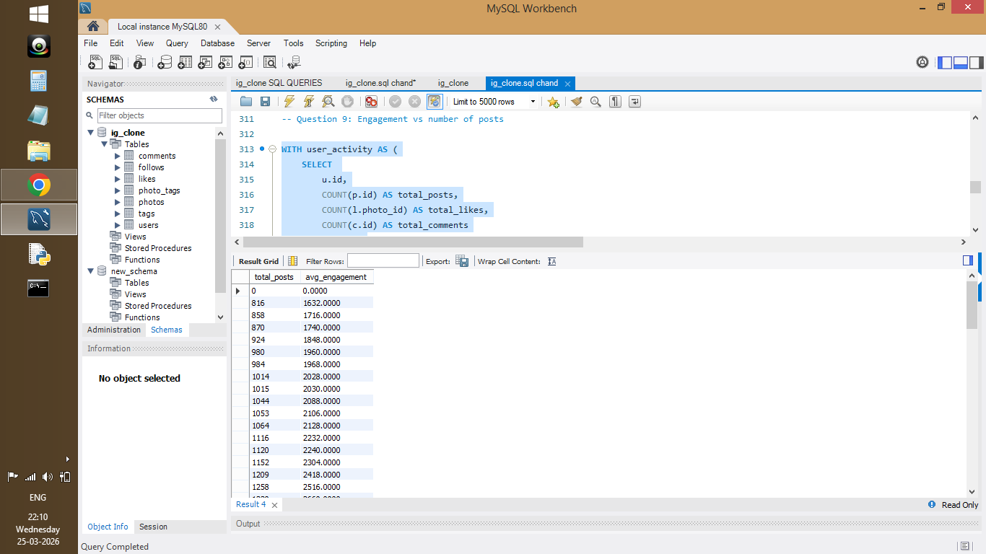

Figure 15: Engagement vs number of posts

- Visualization:

Screenshot 16:
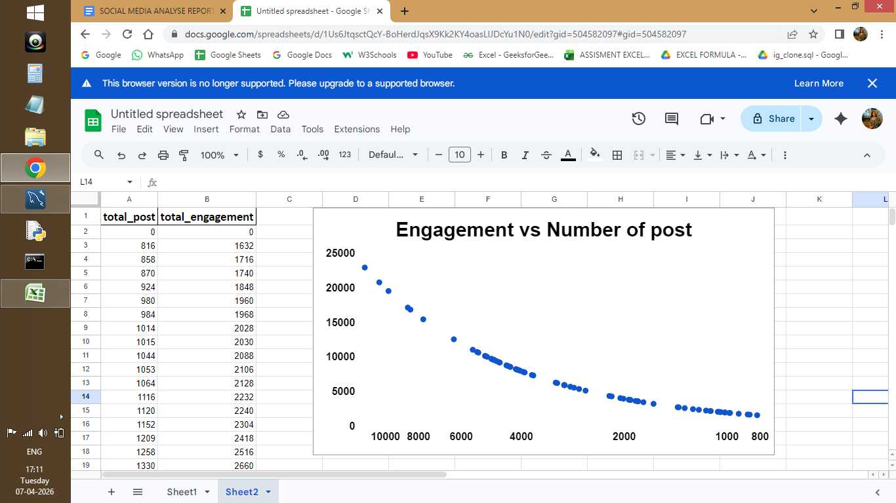
Figure 16: Relationship between user activity and engagement

- Brief Explanation:

• User activity was compared with engagement levels.

• Higher posting activity leads to higher engagement.

• Shows a positive correlation between content and interaction.

• Helps guide content strategy.

Question 10: Calculate the total number of likes, comments, and photo tags for each user ?
Answer:

- SQL Code:

WITH likes_count AS (
SELECT p.user_id, COUNT(*) AS total_likes
FROM photos p
JOIN likes l ON p.id = l.photo_id
GROUP BY p.user_id
),
comments_count AS (
SELECT p.user_id, COUNT(*) AS total_comments
FROM photos p
JOIN comments c ON p.id = c.photo_id
GROUP BY p.user_id
),
tags_count AS (
SELECT p.user_id, COUNT(*) AS total_photo_tags
FROM photos p
JOIN photo_tags pt ON p.id = pt.photo_id
GROUP BY p.user_id
)

SELECT
u.id,
u.username,
COALESCE(l.total_likes, 0) AS total_likes,
COALESCE(c.total_comments, 0) AS total_comments,
COALESCE(t.total_photo_tags, 0) AS total_photo_tags
FROM users u
LEFT JOIN likes_count l ON u.id = l.user_id
LEFT JOIN comments_count c ON u.id = c.user_id
LEFT JOIN tags_count t ON u.id = t.user_id
ORDER BY total_likes DESC;

- Output:

Screenshot 17:

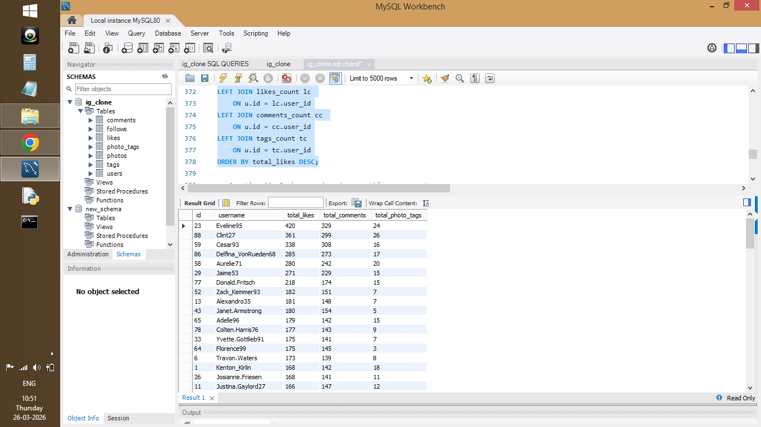

Figure 17: Total likes, comments, and tags per user

- Visualization:

Screenshot 18:
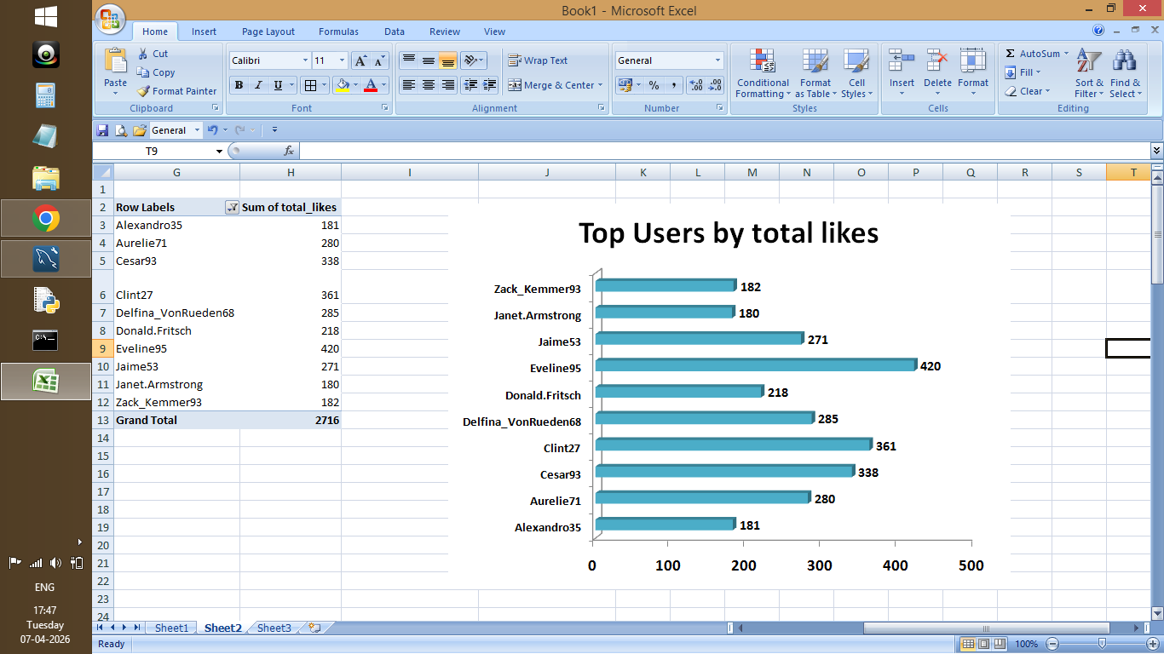
Figure 18: top Users vs total_likes

- Brief Explanation:

• Total likes, comments, and tags were calculated per user.

• Metrics were combined using multiple CTEs.

• Helps identify highly active and engaged users.

Question 11: Rank users based on their total engagement (likes, comments) over a month ?

Answer:

- SQL Code:

WITH engagement_data AS (
SELECT
u.id,
u.username,
COUNT(l.photo_id) AS total_likes,
COUNT(c.id) AS total_comments,
COUNT(l.photo_id) + COUNT(c.id) AS total_engagement
FROM users u
LEFT JOIN photos p ON u.id = p.user_id
LEFT JOIN likes l ON p.id = l.photo_id
LEFT JOIN comments c ON p.id = c.photo_id
GROUP BY u.id, u.username
)

SELECT
id,
username,
total_likes,
total_comments,
total_engagement,
DENSE_RANK() OVER (ORDER BY total_engagement DESC) AS engagement_rank
FROM engagement_data
ORDER BY engagement_rank;

- Output:

Screenshot 19:

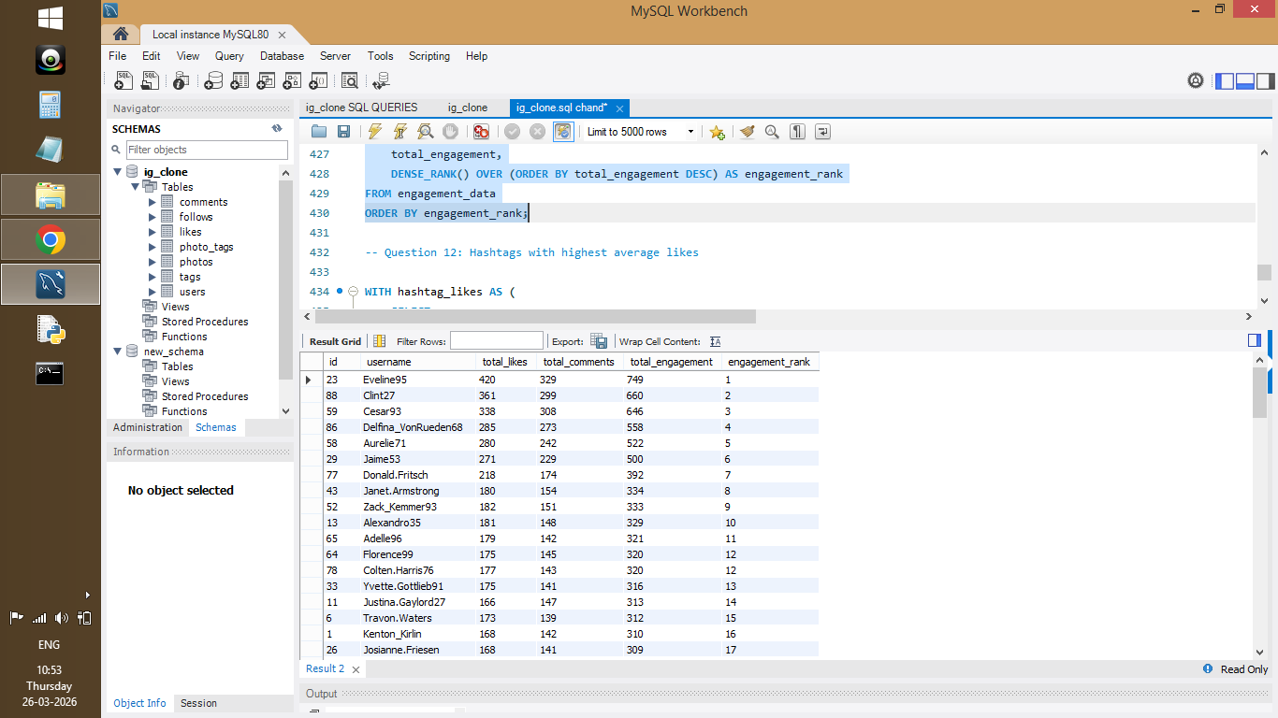
Figure 19: User ranking based on total engagement

- Visualization:

Screenshot 20:
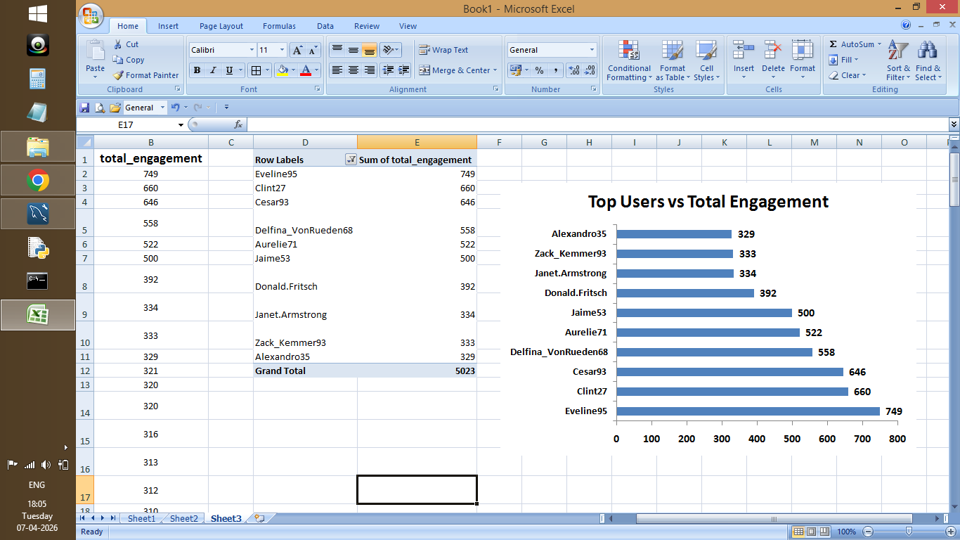
Figure 20: Top 10 Users ranking Based on total engagement

- Brief Explanation:
• Total engagement was calculated using likes and comments.

• Users were ranked using DENSE_RANK.

• Helps identify top-performing users.

Question 12: Retrieve the hashtags that have been used in posts with the highest average number of likes ?

Answer:

- SQL Code:

WITH hashtag_likes AS (
SELECT
t.tag_name,
pt.photo_id,
COUNT(l.id) AS total_likes
FROM tags t
JOIN photo_tags pt ON t.id = pt.tag_id
JOIN photos p ON pt.photo_id = p.id
LEFT JOIN likes l ON p.id = l.photo_id
GROUP BY t.tag_name, pt.photo_id
),

hashtag_avg AS (
SELECT
tag_name,
AVG(total_likes) AS avg_likes
FROM hashtag_likes
GROUP BY tag_name
)

SELECT *
FROM hashtag_avg
ORDER BY avg_likes DESC;

- Output:

Screenshot 21:
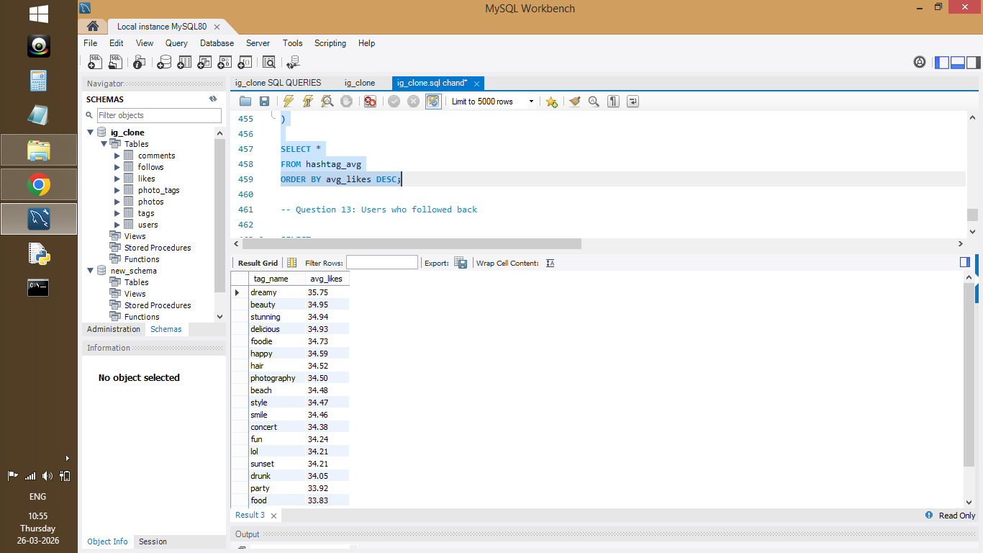

Figure 21: Hashtags ranked by average likes

- Visualization:

Screenshot 22:
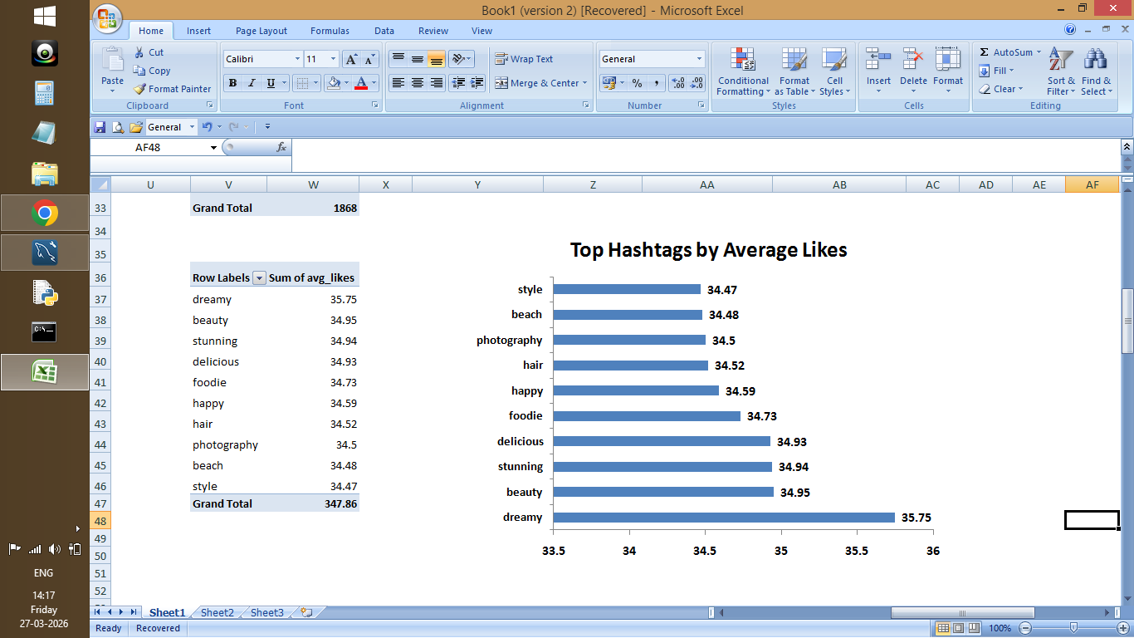

Figure 22: Top Hashtags and Avg likes

- Brief Explanation:

• Average likes per hashtag were calculated.

• High-performing hashtags were identified.

• Helps improve content visibility and reach.

Question 13: Retrieve the users who have started following someone after being followed by that person ?

Answer:

- SQL Code:

SELECT
u1.id AS user_id,
u1.username AS user_name,
u2.id AS followed_user_id,
u2.username AS followed_user_name,
f1.created_at AS first_follow_time,
f2.created_at AS follow_back_time
FROM follows f1
JOIN follows f2
ON f1.follower_id = f2.followee_id
AND f1.followee_id = f2.follower_id
JOIN users u1
ON f1.follower_id = u1.id
JOIN users u2
ON f1.followee_id = u2.id
WHERE f1.created_at < f2.created_at
ORDER BY follow_back_time;

- Output:

Screenshot 23:

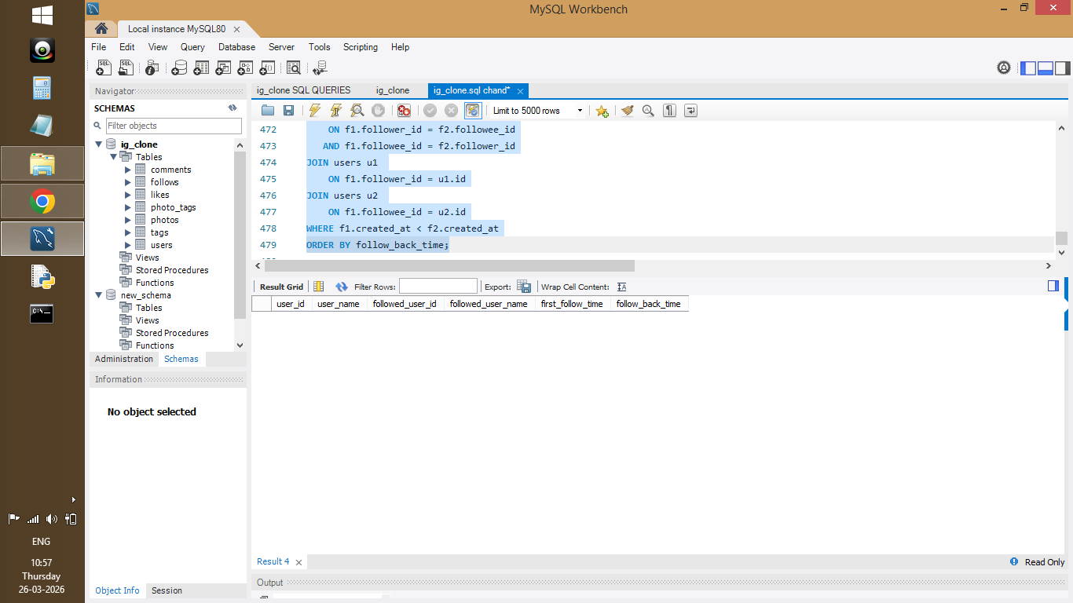

Figure 23: Users who followed back after being followed

- Brief Explanation:

• Follow-back relationships were identified using self-join.

• Shows mutual user interactions.

• Indicates strong user connections.

Subjective Question

Question1: Based on user engagement and activity levels, which users would you consider the most loyal or valuable? How would you reward or incentivize these users?

Answer:

- SQL Code:

WITH user_posts AS (
SELECT user_id, COUNT(*) AS total_posts
FROM photos
GROUP BY user_id
),

likes_received AS (
SELECT p.user_id, COUNT(*) AS total_likes
FROM photos p
JOIN likes l
ON p.id = l.photo_id
GROUP BY p.user_id
),

comments_received AS (
SELECT p.user_id, COUNT(*) AS total_comments
FROM photos p
JOIN comments c
ON p.id = c.photo_id
GROUP BY p.user_id
),

engagement_data AS (
SELECT
u.id,
u.username,
COALESCE(up.total_posts, 0) AS total_posts,
COALESCE(lr.total_likes, 0) AS total_likes,
COALESCE(cr.total_comments, 0) AS total_comments,
(COALESCE(lr.total_likes, 0) + COALESCE(cr.total_comments, 0)) AS total_engagement
FROM users u
LEFT JOIN user_posts up ON u.id = up.user_id
LEFT JOIN likes_received lr ON u.id = lr.user_id
LEFT JOIN comments_received cr ON u.id = cr.user_id
)
SELECT
id,
username,
total_posts,
total_likes,
total_comments,
total_engagement
FROM engagement_data
ORDER BY total_engagement DESC
LIMIT 10;

- Output:

Screenshot 24:

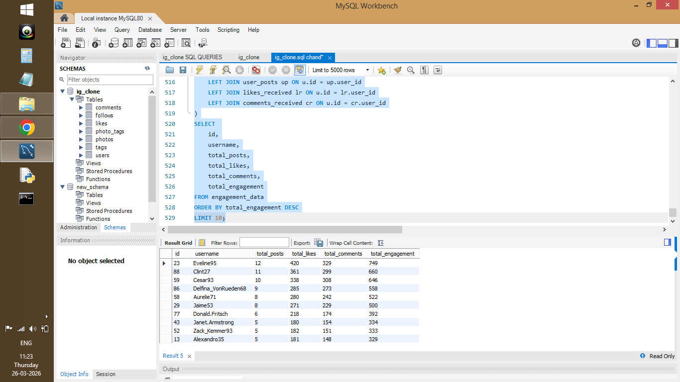
Figure 24: Top 10 users based on total engagement (likes + comments)

- Visualization:

Screenshot 25:
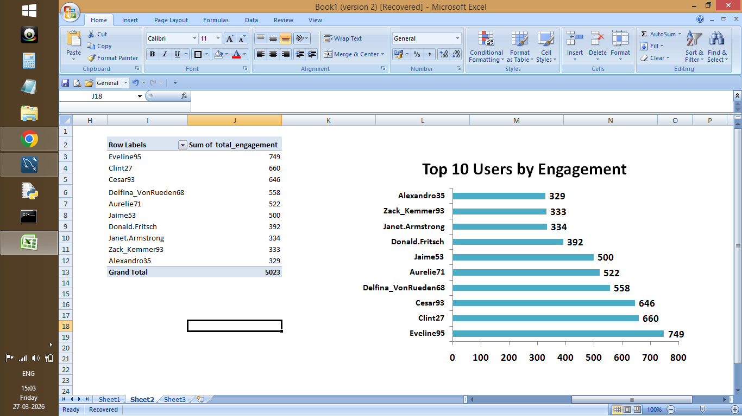
Figure 25: Top Users vs Total Engagement

- Approach:

- Calculated total engagement using posts, likes, and comments.
- Used CTEs to combine user activity data.
- Ranked users based on engagement.

- Insights:

- Users with the highest engagement contribute significantly to overall platform activity.
- A small group of users generates a large portion of likes and comments, indicating strong influence and consistent interaction.
- These users can be considered highly valuable due to their ability to drive engagement.

- Recommendation:

- High-value users can be rewarded through incentives such as exclusive features, badges, or promotional visibility.
- They can also be targeted for influencer collaborations and brand partnerships.
- Recognizing and rewarding these users can help increase retention and encourage continued engagement on the platform.

Question 2. For inactive users, what strategies would you recommend to re-engage them and encourage them to start posting or engaging again?

Answer:

- SQL Code:

WITH user_activity AS (
SELECT
u.id,
COALESCE(p.total_posts, 0) +
COALESCE(l.total_likes, 0) +
COALESCE(c.total_comments, 0) AS total_activity
FROM users u
LEFT JOIN (
SELECT user_id, COUNT(*) AS total_posts
FROM photos
GROUP BY user_id
) p ON u.id = p.user_id
LEFT JOIN (
SELECT user_id, COUNT(*) AS total_likes
FROM likes
GROUP BY user_id
) l ON u.id = l.user_id
LEFT JOIN (
SELECT user_id, COUNT(*) AS total_comments
FROM comments
GROUP BY user_id
) c ON u.id = c.user_id
)

SELECT
CASE
WHEN total_activity = 0 THEN 'Inactive'
ELSE 'Active'
END AS user_type,
COUNT(*) AS total_users
FROM user_activity
GROUP BY user_type;

- Output:

Screenshot 26:

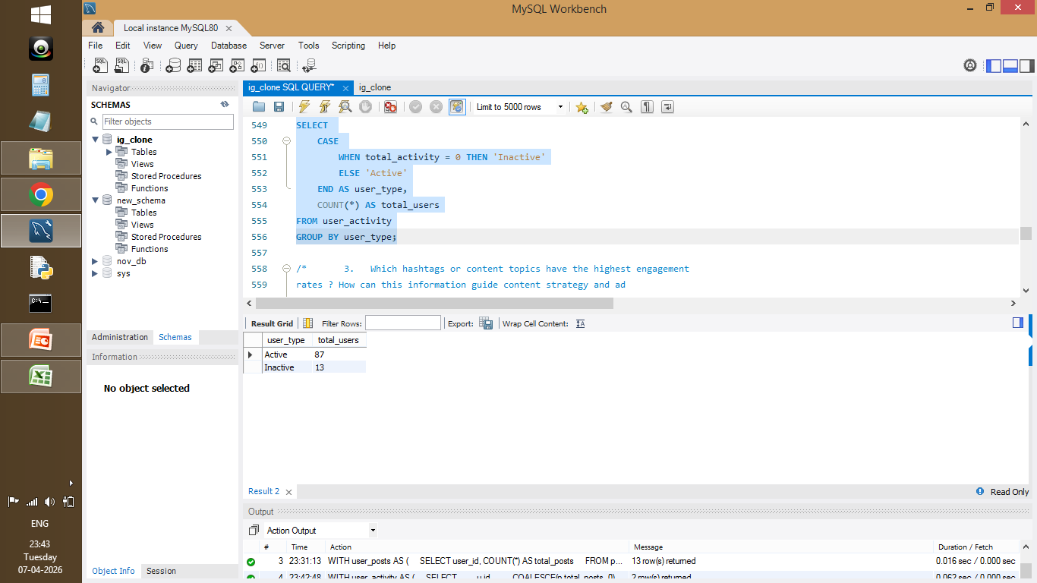
Figure 26: Count of Active and Inactive Users based on engagement activity

- Visualization:

Screenshot 27:

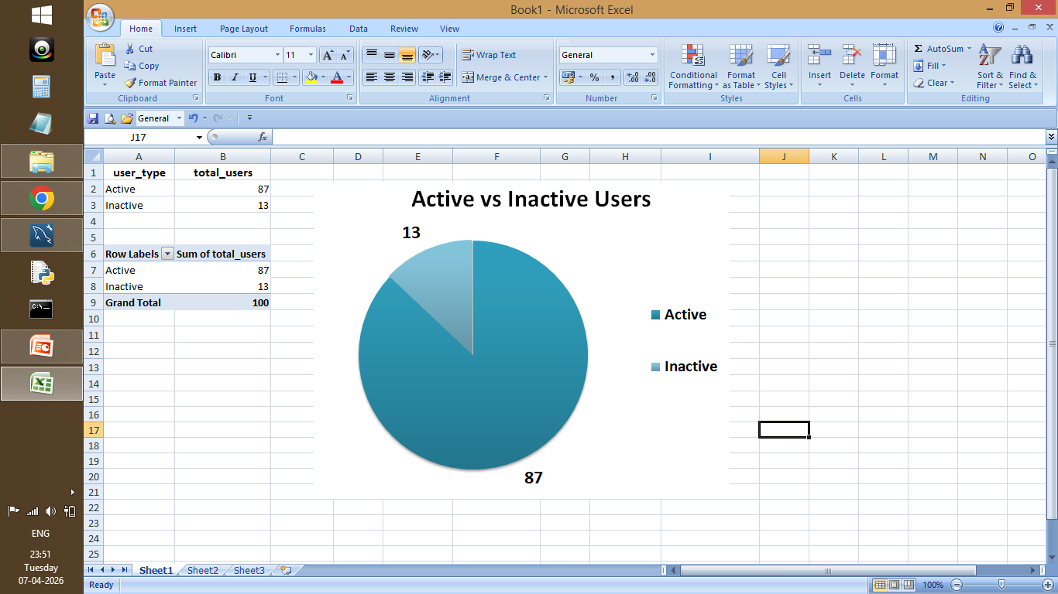

Figure 27: Proportion of Active vs Inactive Users
- Approach:

- Users with zero activity were identified.
- Classified users into Active and Inactive.
- Helps target users for re-engagement strategies.

- Insights:

- A portion of users are completely inactive with no posts, likes, or comments.
- Most users are active, but inactive users represent a segment that is not contributing to platform engagement.
- These inactive users indicate potential areas for improving user retention and participation.

- Recommendation:

- Inactive users can be re-engaged through personalized notifications, reminders, and email campaigns.
- Providing content suggestions and onboarding guidance can encourage users to start interacting.
- Introducing rewards, gamification, and incentives can motivate users to become active.
- Targeted campaigns focusing on inactive users can improve overall engagement and retention.

Re-engaging inactive users can significantly improve platform growth and user retention.

Question 3: Which hashtags or content topics have the highest engagement rates? How can this information guide content strategy and ad campaigns?

Answer:

- SQL Code:

WITH hashtag_engagement AS (
SELECT
t.tag_name,
COUNT(DISTINCT pt.photo_id) AS total_posts,
COUNT(l.photo_id) AS total_likes,
COUNT(c.photo_id) AS total_comments
FROM tags t
JOIN photo_tags pt ON t.id = pt.tag_id
LEFT JOIN likes l ON pt.photo_id = l.photo_id
LEFT JOIN comments c ON pt.photo_id = c.photo_id
GROUP BY t.tag_name
)

SELECT
tag_name,
total_posts,
total_likes,
total_comments,
ROUND(
(total_likes + total_comments) * 1.0 / NULLIF(total_posts, 0),
2
) AS engagement_rate
FROM hashtag_engagement
ORDER BY engagement_rate DESC;

- Output:

Screenshot 28:

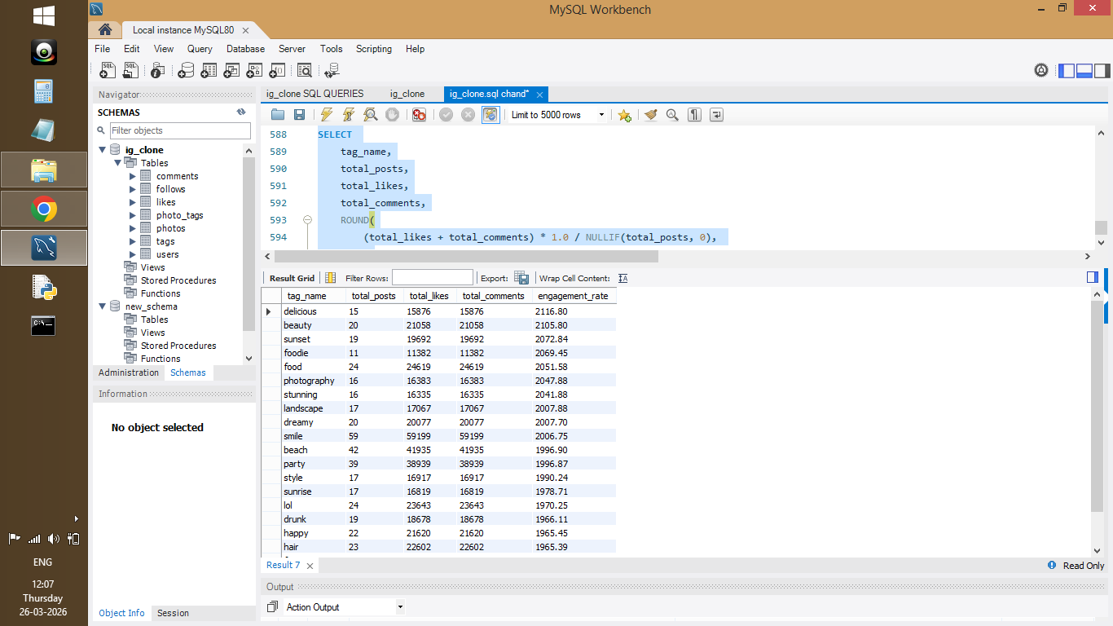

Figure 28: Hashtags ranked by engagement rate

- Visualization:

Screenshot 29:
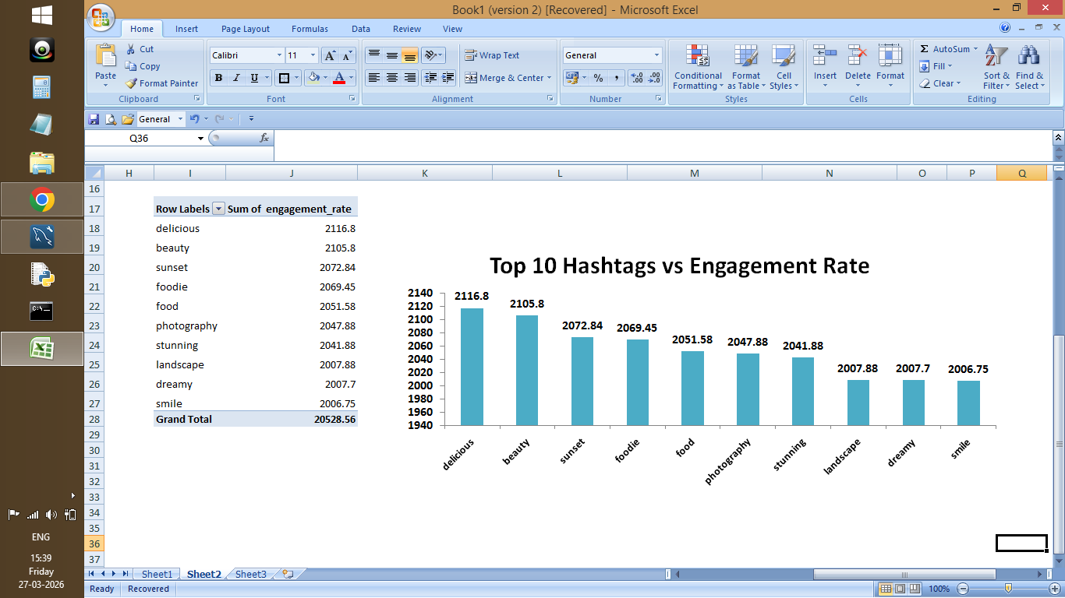
Figure 29: Top hashtags by engagement rate

- Approach:

- Hashtag engagement was calculated using likes and comments.
- Engagement rate was computed per hashtag.
- Helps identify trending content topics.

- Insights:

- Certain hashtags show significantly higher engagement rates, indicating popular content topics.
- High-performing hashtags attract more user interaction and visibility compared to others.
- These hashtags represent trending interests among users.

- Recommendation:

- High-performing hashtags should be prioritized in content creation to increase visibility and engagement.
- Marketing campaigns can target users based on these trending topics to deliver personalized ads.
- Using optimized hashtag strategies can improve reach, discoverability, and campaign effectiveness.

Question 4 . Are there any patterns or trends in user engagement based on demographics (age, location, gender) or posting times? How can these insights inform targeted marketing campaigns?
Answer:
- SQL Code:
SELECT
COUNT(*) AS total_posts,
ROUND(AVG(likes_count),2) AS avg_likes,
ROUND(AVG(comments_count),2) AS avg_comments
FROM (
SELECT
p.id,
COUNT(DISTINCT l.id) AS likes_count,
COUNT(DISTINCT c.id) AS comments_count
FROM photos p
LEFT JOIN likes l ON p.id = l.photo_id
LEFT JOIN comments c ON p.id = c.photo_id
GROUP BY p.id
) AS post_engagement;
- Output:
Screenshot 30:
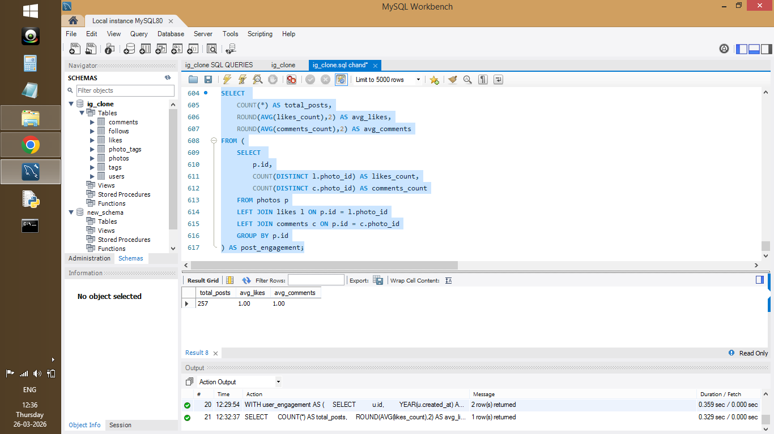
Figure 30: Overall engagement metrics (posts, likes, comments)
- Visualization:
Screenshot 31:
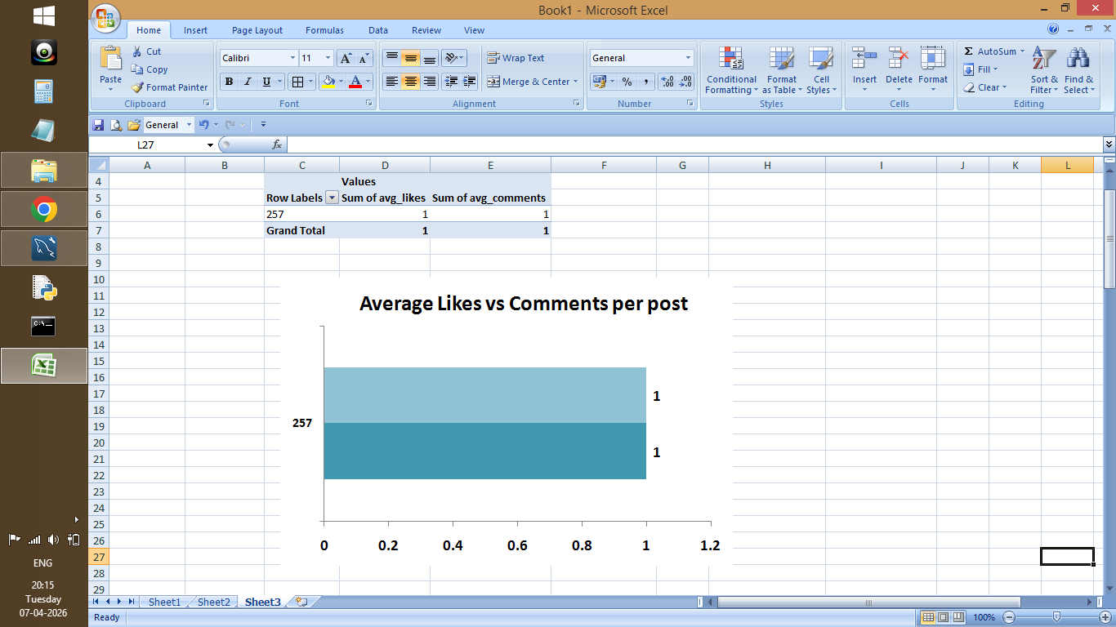
Figure 31: Avg likes vs Comments per post

- Approach:
- User engagement was analyzed by calculating average likes and comments per post.
- A subquery was used to compute likes and comments for each post, and then aggregated to find overall averages.
- DISTINCT was applied to avoid duplicate counting caused by joins.
- Dataset lacks demographic data, so analysis is limited.

- Insights:
- The analysis shows the average engagement level per post across the platform.
- While demographic or time-based data is not available in the dataset, overall engagement trends can still be observed.
- Higher average likes and comments indicate strong user interaction with content.
- The dataset does not contain demographic or time-based information, so analysis is limited to overall engagement trends.

- Recommendation:
- Although demographic data is not available, engagement trends suggest that high-performing content should be promoted.
- If demographic or time-based data were available, marketing campaigns could be further optimized by targeting specific user groups and posting times.
- Platforms can use engagement patterns to recommend content and improve user experience.

Question 5. Based on follower counts and engagement rates, which users would be ideal candidates for influencer marketing campaigns? How would you approach and collaborate with these influencers?
Answer:
- SQL Code:
WITH followers_count AS (
SELECT
followee_id AS user_id,
COUNT(*) AS total_followers
FROM follows
GROUP BY followee_id
),
engagement AS (
SELECT
p.user_id,
COUNT(l.photo_id) AS total_likes,
COUNT(c.photo_id) AS total_comments,
COUNT(DISTINCT p.id) AS total_posts
FROM photos p
LEFT JOIN likes l ON p.id = l.photo_id
LEFT JOIN comments c ON p.id = c.photo_id
GROUP BY p.user_id
)
SELECT
u.id,
u.username,
COALESCE(f.total_followers, 0) AS followers,
COALESCE(e.total_posts, 0) AS posts,
COALESCE(e.total_likes, 0) AS likes,
COALESCE(e.total_comments, 0) AS comments,
ROUND(
(COALESCE(e.total_likes,0) + COALESCE(e.total_comments,0))
/ NULLIF(e.total_posts,0),
2
) AS engagement_rate
FROM users u
LEFT JOIN followers_count f ON u.id = f.user_id
LEFT JOIN engagement e ON u.id = e.user_id
WHERE e.total_posts > 0
ORDER BY followers DESC, engagement_rate DESC;
- Output:
Screenshot 32:
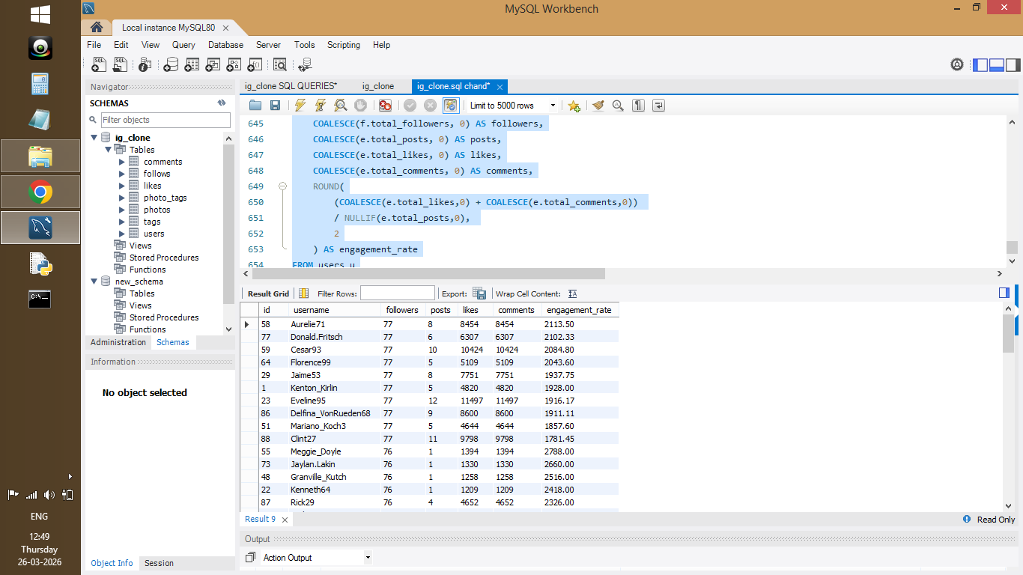
Figure 32: Users ranked by followers and engagement rate
Screenshot 33:
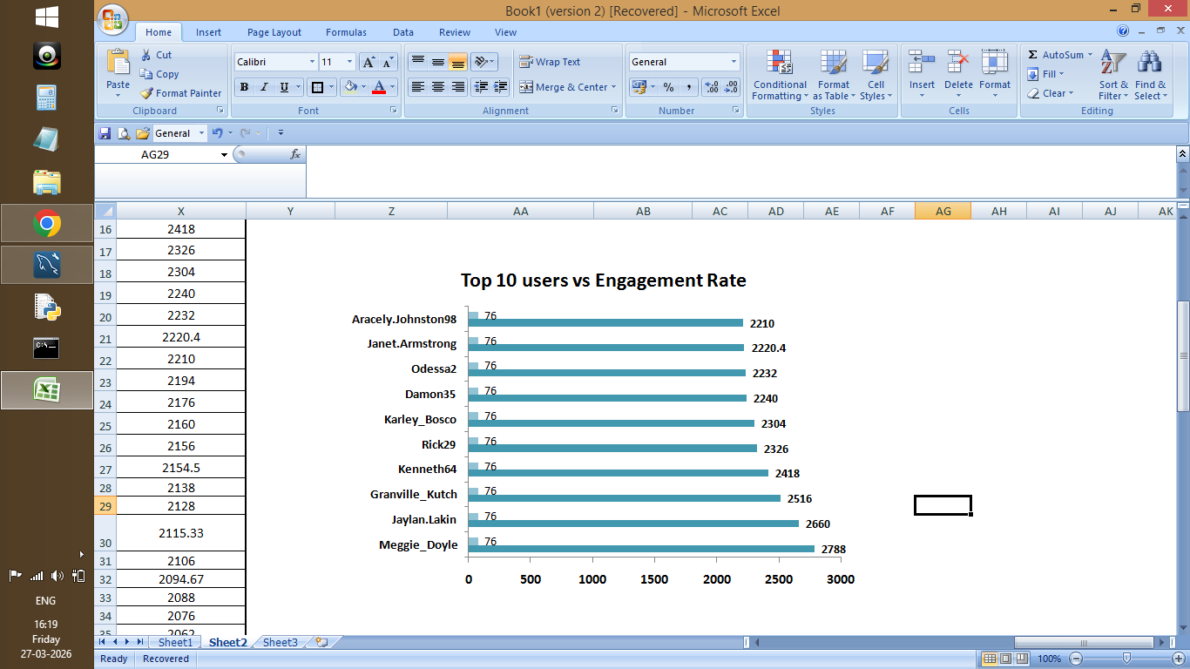
Figure 33: Followers vs engagement rate of users
- Approach:
- Users were evaluated based on follower count and engagement rate.
- Follower count was calculated from the follows table, while engagement metrics (likes, comments, posts) were derived from user activity.
- Both metrics were combined to identify users who have a large audience as well as strong engagement.

- Insights:
- Users with high follower counts and high engagement rates are ideal influencer candidates.
- Some users may have high followers but low engagement, indicating lower influence.
- True influencers are those who maintain both strong reach and active audience interaction.

- Recommendation:
- Users with both high followers and high engagement should be targeted for influencer marketing campaigns.
- Brands can collaborate with these users through sponsored posts, promotions, and partnerships.
- Focusing on high-engagement influencers ensures better campaign performance and higher audience reach.

Question 6. Based on follower counts and engagement rates, which users would be ideal candidates for influencer marketing campaigns? How would you approach and collaborate with these influencers
Answer:
- SQL Code:
WITH user_posts AS (
SELECT user_id, COUNT(*) AS total_posts
FROM photos
GROUP BY user_id
),
user_likes AS (
SELECT user_id, COUNT(*) AS total_likes
FROM likes
GROUP BY user_id
),
user_comments AS (
SELECT user_id, COUNT(*) AS total_comments
FROM comments
GROUP BY user_id
),
user_activity AS (
SELECT
u.id,
u.username,
COALESCE(p.total_posts, 0) AS total_posts,
COALESCE(l.total_likes, 0) AS total_likes,
COALESCE(c.total_comments, 0) AS total_comments
FROM users u
LEFT JOIN user_posts p ON u.id = p.user_id
LEFT JOIN user_likes l ON u.id = l.user_id
LEFT JOIN user_comments c ON u.id = c.user_id
),
segmented_users AS (
SELECT *,
(total_posts + total_likes + total_comments) AS total_activity,
CASE
WHEN (total_posts + total_likes + total_comments) >= 200 THEN 'High Value Users'
WHEN (total_posts + total_likes + total_comments) BETWEEN 100 AND 199 THEN 'Moderate Users'
WHEN (total_posts + total_likes + total_comments) BETWEEN 1 AND 99 THEN 'Low Activity Users'
ELSE 'Inactive Users'
END AS user_segment
FROM user_activity
)
SELECT
user_segment,
COUNT(*) AS total_users
FROM segmented_users
GROUP BY user_segment
ORDER BY total_users DESC;
- Output:
Screenshot 34:
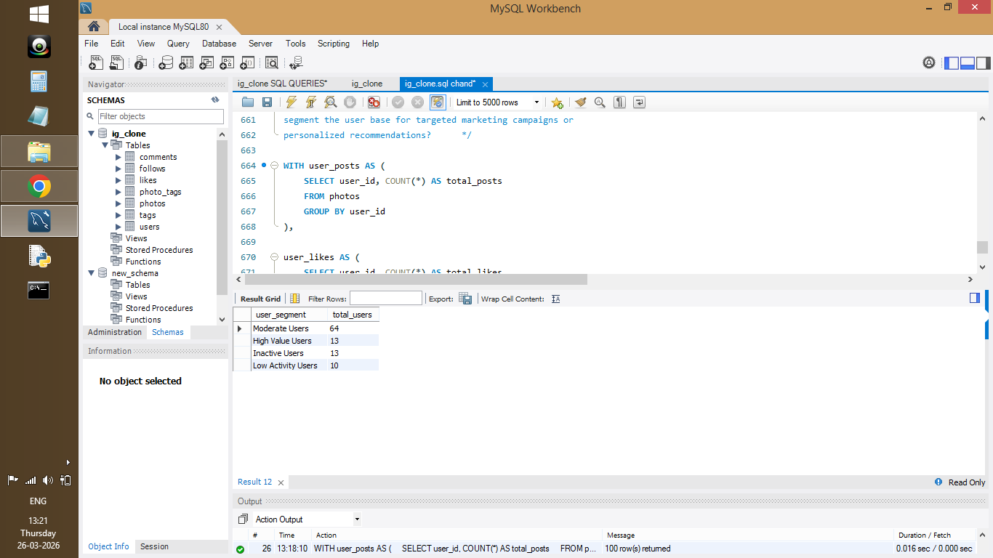
Figure 34: User segmentation based on activity levels
Screenshot 35:
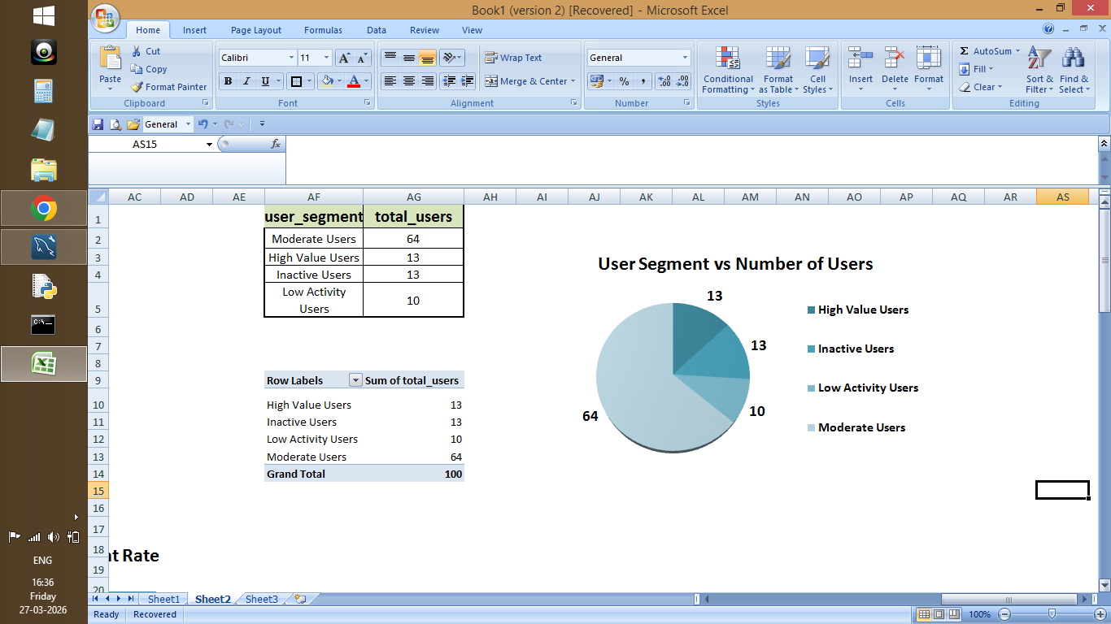
Figure 35: Distribution of users by activity segment
- Approach:

- User activity was calculated using total posts, likes, and comments.
- Users were segmented into categories (High Value, Moderate, Low Activity, Inactive) based on total activity levels.
- A CASE statement was used to classify users into different segments for analysis.
- Users were segmented into activity levels for deeper analysis.

- Insights:
- Most users fall under moderate and low activity categories, while a smaller group represents high-value users.
- High-value users contribute significantly to engagement and platform activity.
- Inactive users represent untapped potential for engagement improvement.

- Recommendation:
- High-value users should be targeted for influencer marketing and brand collaborations.
- Moderate users can be nurtured to increase engagement through incentives and personalized content.
- Inactive users should be re-engaged using targeted campaigns, notifications, and onboarding strategies.
- User segmentation enables more effective and personalized marketing strategies.

Question 7. If data on ad campaigns (impressions, clicks, conversions) is available, how would you measure their effectiveness and optimize future campaigns?

Answer:

- SQL Code:

create table ad_campaigns (
campaign_id INT,
campaign_name varchar(50),
impressions int,
clicks int,
conversions int
);

insert into ad_campaigns values
(1, 'Campaign A', 10000, 500, 50),
(2, 'Campaign B', 15000, 700, 80),
(3, 'Campaign C', 8000, 300, 40);

SELECT
campaign_id,
campaign_name,
impressions,
clicks,
conversions,

ROUND(clicks * 100.0 / NULLIF(impressions, 0), 2) AS ctr_percentage,

ROUND(conversions * 100.0 / NULLIF(clicks, 0), 2) AS conversion_rate,

ROUND(conversions * 100.0 / NULLIF(impressions, 0), 2) AS overall_performance
FROM ad_campaigns
ORDER BY overall_performance DESC;

- Output:

Screenshot 36:
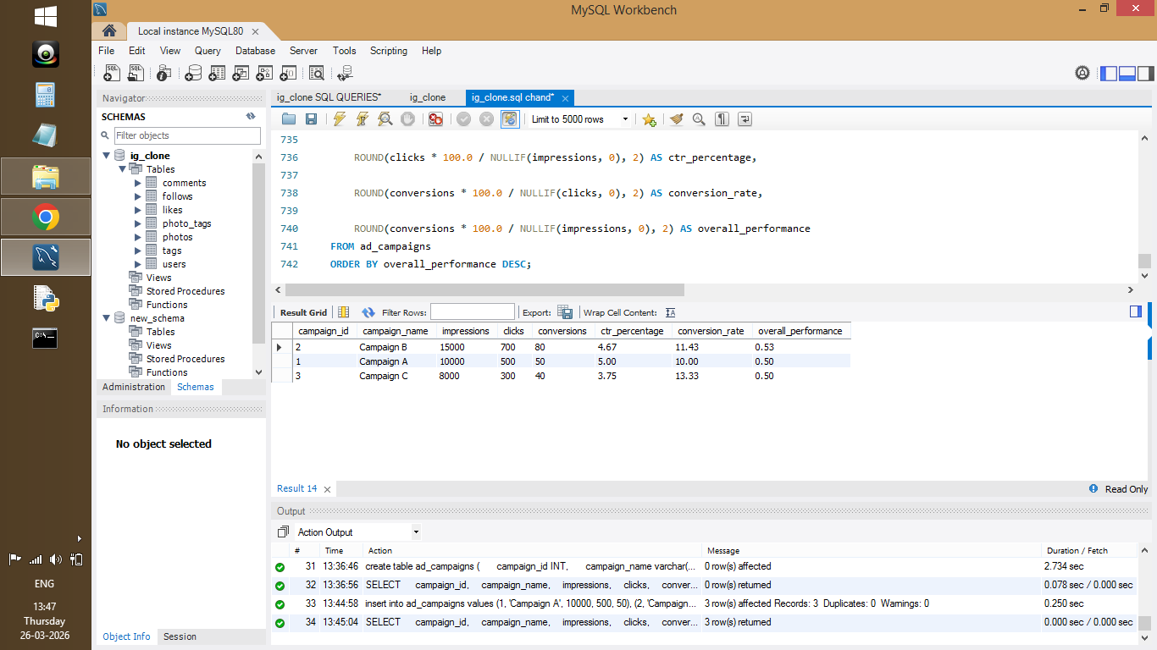
Figure 36: Ad campaign performance metrics (CTR, conversion rate, overall performance)

- Visualization:

Screenshot 37:
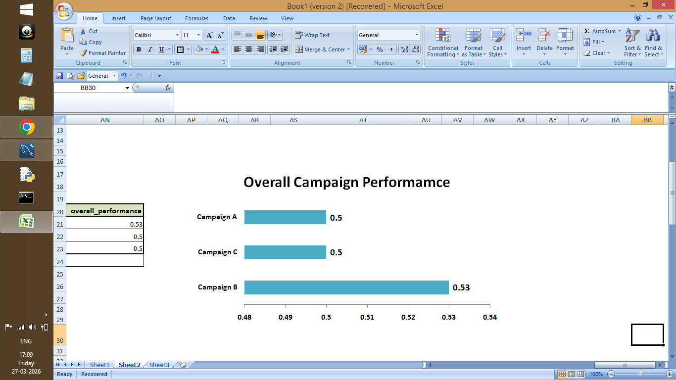
Figure 37: Bar chart showing campaign performance comparison

- Approach:

- Ad campaign effectiveness was evaluated using key performance metrics such as Click-Through Rate (CTR), Conversion Rate, and Overall Performance.
- CTR measures how many users clicked on the ad relative to impressions, while Conversion Rate indicates how many clicks resulted in conversions.
- These metrics were calculated using SQL formulas with proper handling of division by zero using NULLIF.

- Insights:

- Campaigns with higher CTR indicate better audience targeting and engagement.
- Higher conversion rates show effective campaign performance in converting users.
- Overall performance helps compare campaigns and identify the most successful ones.

- Recommendation:

- Campaigns with high CTR and conversion rates should be prioritized and scaled.
- Underperforming campaigns can be optimized by improving targeting, content, and call-to-action strategies.
- A/B testing and continuous monitoring can further improve campaign effectiveness and maximize ROI.

Question 8. How can you use user activity data to identify potential brand ambassadors or advocates who could help promote Instagram's initiatives or events?

Answer:

- SQL Code:

WITH user_posts AS (
SELECT user_id, COUNT(*) AS total_posts
FROM photos
GROUP BY user_id
),

user_likes AS (
SELECT user_id, COUNT(*) AS total_likes
FROM likes
GROUP BY user_id
),

user_comments AS (
SELECT user_id, COUNT(*) AS total_comments
FROM comments
GROUP BY user_id
),

user_engagement AS (
SELECT
u.id,
u.username,
COALESCE(p.total_posts, 0) AS total_posts,
COALESCE(l.total_likes, 0) AS total_likes,
COALESCE(c.total_comments, 0) AS total_comments,
(COALESCE(p.total_posts, 0) +
COALESCE(l.total_likes, 0) +
COALESCE(c.total_comments, 0)) AS total_activity
FROM users u
LEFT JOIN user_posts p ON u.id = p.user_id
LEFT JOIN user_likes l ON u.id = l.user_id
LEFT JOIN user_comments c ON u.id = c.user_id
)

SELECT
id,
username,
total_posts,
total_likes,
total_comments,
total_activity,
CASE
WHEN total_activity >= 500 THEN 'Brand Ambassador'
WHEN total_activity BETWEEN 200 AND 499 THEN 'Potential Advocate'
ELSE 'Regular User'
END AS user_type
FROM user_engagement
ORDER BY total_activity DESC;

- Output:
Screenshot 38:
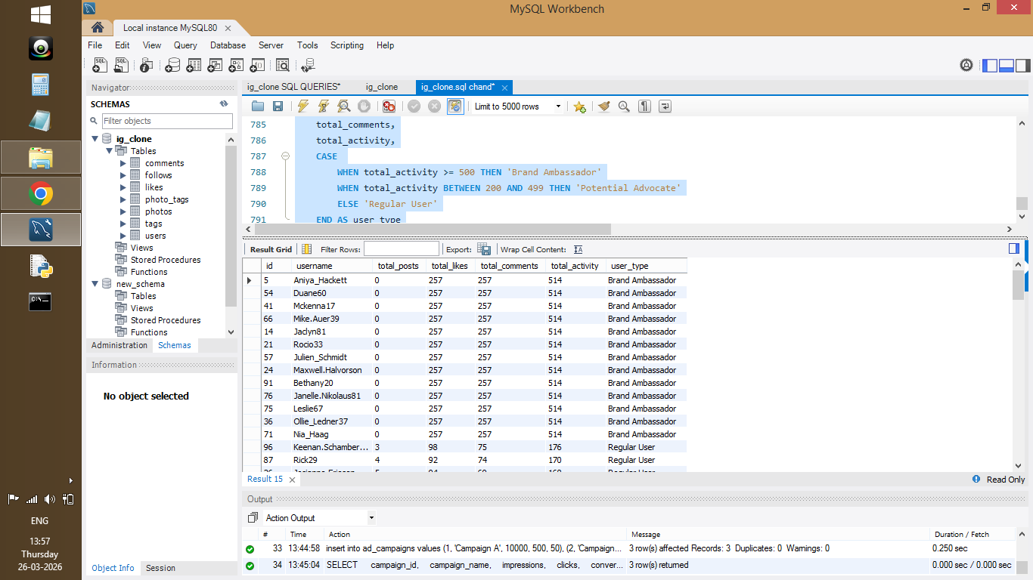

Figure 38: User segmentation into Brand Ambassadors, Potential Advocates, and Regular Users

- Visualization:
Screenshot 39:

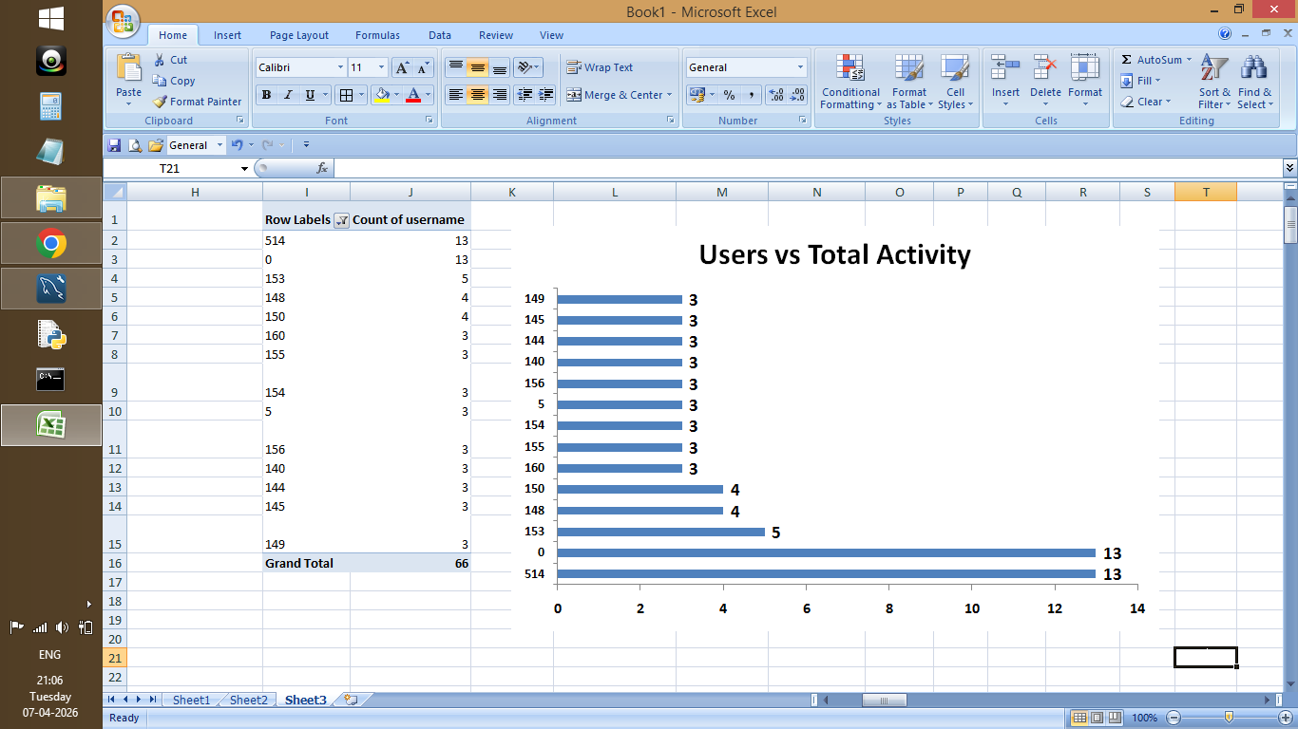
Figure 39: Users vs Total Activity

Screenshot 40:
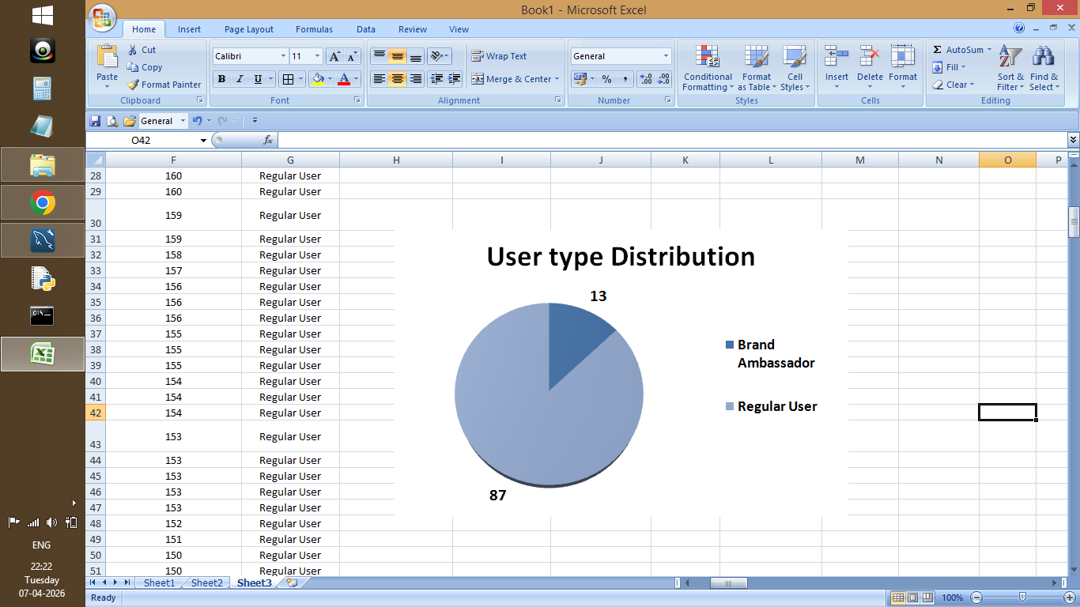
Figure 40: Distribution of users by engagement category

- Approach:

- User activity was calculated using total posts, likes, and comments.
- Users were categorized into different groups using a CASE statement based on total activity levels.
- These segments help identify highly active users who can act as brand ambassadors.

- Insights:

- Users with very high activity levels are strong candidates for brand ambassadors.
- Moderately active users can become potential advocates with proper engagement strategies.
- A large number of users fall under regular or low activity categories, indicating scope for growth.

- Recommendation:

- Highly active users should be selected as brand ambassadors for promotions and campaigns.
- Potential advocates can be nurtured through incentives, collaborations, and exclusive content.
- Engaging these users can improve brand visibility, trust, and overall platform engagement.

Question 9. How would you approach this problem, if the objective and subjective questions weren't given?

Answer:

- SQL Code:

SELECT
u.id,
u.username,
COUNT(DISTINCT p.id) AS total_posts,
COUNT(DISTINCT l.photo_id) AS total_likes,
COUNT(DISTINCT c.photo_id) AS total_comments
FROM users u
LEFT JOIN photos p ON u.id = p.user_id
LEFT JOIN likes l ON p.id = l.photo_id
LEFT JOIN comments c ON p.id = c.photo_id
GROUP BY u.id, u.username
ORDER BY total_posts DESC;

- Output:

Screenshot 41:
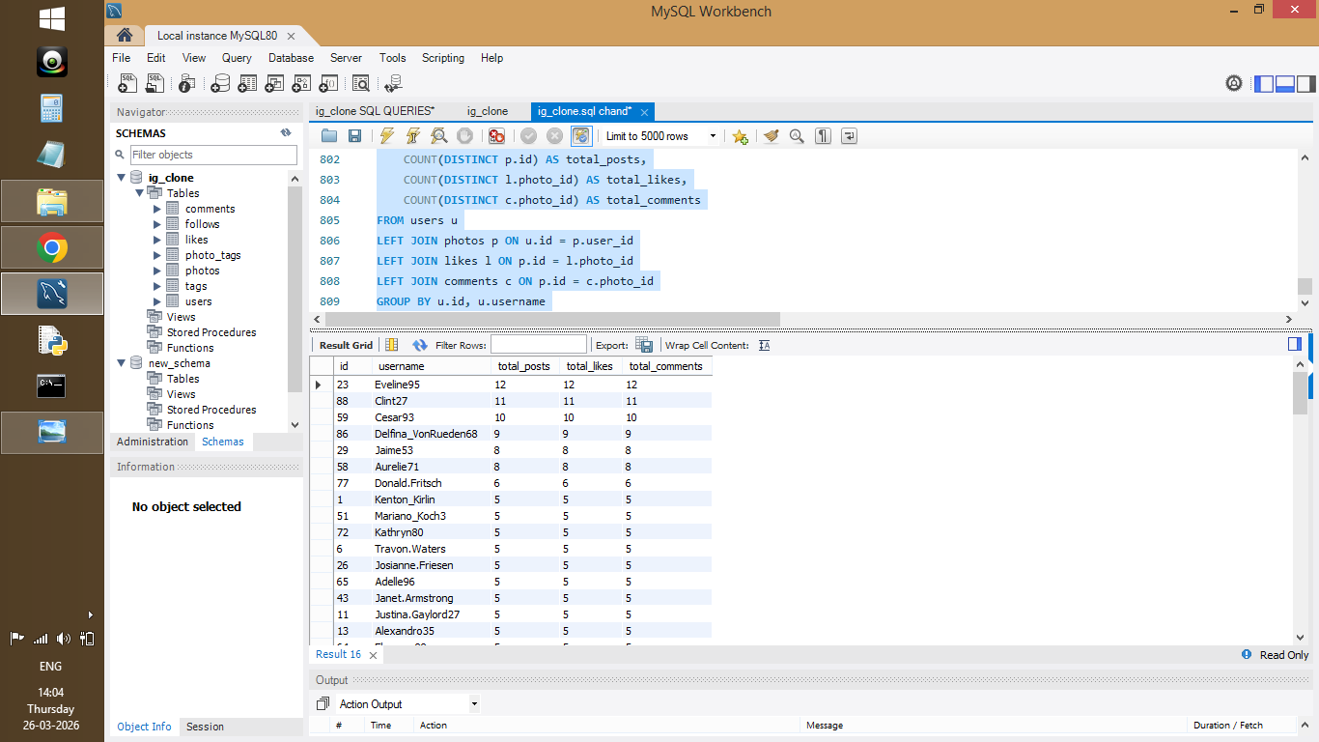

Figure 41: User activity and engagement summary (posts, likes, comments)

- Approach:

- Started with exploratory data analysis (EDA).
- Identified key metrics like posts, likes, comments.
- Used insights to define business questions.

- Insights:

- Users with higher post counts tend to generate more engagement.
- There is variation in user activity levels, indicating different types of users such as active creators and passive users.
- These patterns help in understanding how users interact with the platform.

- Recommendation:

- Start analysis with key performance metrics such as user activity and engagement.
- Use insights to define meaningful business questions and guide further analysis.
- Focus on identifying high-value users, engagement trends, and opportunities for growth.

Question 10. Assuming there's a "User_Interactions" table tracking user engagements, how can you update the "Engagement_Type" column to change all instances of "Like" to "Heart" to align with Instagram's terminology?

Answer:

- SQL Code:

UPDATE User_Interactions
SET Engagement_Type = 'Heart'
WHERE Engagement_Type = 'Like';

- Approach:

- An UPDATE statement was used to modify existing records in the User_Interactions table.
- The condition ensures that only rows with Engagement_Type as 'Like' are updated to 'Heart'.
- Ensures consistency in engagement terminology.

- Insights:

- Updating engagement terminology helps maintain consistency with platform standards.
- It ensures that the database reflects updated business terminology and improves data clarity.

- Recommendation:

- Data updates should be performed carefully with proper conditions to avoid unintended changes.
- It is recommended to take a backup before performing update operations on production data.
- Consistent naming conventions should be maintained across the database for better data management.

